Year 7 home learning – Judaism
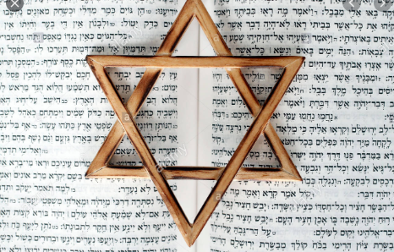

This booklet will cover the Judaism unit. Contact your teacher if you have any questions.

Keywords – complete the missing words to learn the keywords for this topic

1. Covenant: An agreement, contract or promise given to the Jews by God.
2. Kosher: Food that is ‘fit’ or ‘P…………….’. It includes the types of food that Jewish people are able to eat and the way in which it is prepared. For example, Jews are not allowed to mix meat with dairy in the same m………….
3. Messiah: (or Mashiach) This means the ‘a……………… one’. Jews believe that their Messiah will be chosen by G_d to put an end to evil in the world. The Messiah will unite the nations and return the Jews to the P………………………. L……..
4. Mitzvot: This means ‘commandment’. Jewish people observe (follow) 613 mitzvot. Included in this number is the original 10 Commandments, given to M…………… on Mount Sinai.
5. S………………………….: (or Sabbath) This is the holy day – or special day of rest – for Jewish people. Lasting 25 hours, it begins at s…………………. on Friday night and ends at sunset on Saturday night. It is a day of rest and celebration. No w…………… can be carried out on this day.
6. Shekinah: This means ‘dwelling’. It identifies the divine p……………………. of G_d. For example, when Moses spoke to G-d through the burning b…………..
7. Synagogue: This means ‘house of assembly’ and is where Jewish people come together as a c…………………………. to worship G-d. It can also be translated as ‘s………….’ as it is where people come to learn about G-d.
8. Torah: This means ‘t………………………….’ and is the law of God that was revealed to Moses and recorded in the first five books of the H…………………………. Scriptures.
Missing words: community anointed proper bush Hebrew sunset
Meal Moses work Promised Land presence school
Shabbat teachings
Lesson 1 - Introduction to Judaism
Learning objectives
- Understand why it is important to learn about Judaism
- Explain basic beliefs and denominations of Judaism
Why do we learn about Judaism?
1 - Judaism, in addition to being a religion in its own right, is the parent religion of both Christianity and Islam.
2 - Jews have played a role in some of the most important developments in modern times, from physics to psychoanalysis to post-modernism.
3 – There are approximately 14 million Jews in the world today. It has only just recovered to the pre holocaust population (estimated 6 million Jews killed).
4 – An estimated 290,000 Jews in the UK today.

Therefore… it is important that you learn about it!
Starter
Use the provided website to learn some facts about Judaism and answer the questions here or in your book/paper.
https://www.history.com/topics/religion/judaism

- Approximately how old is Judaism?

- How many Gods do Jews believe in?

- Where do Jewish people worship?

- Where do most Jewish people live today?

- Approximately how many Jews are there in the world today?

- What is their sacred (special) text called?

- Who is considered the founder of Judaism?

Now self-mark your answers page

Main task 1
Watch the following YouTube programme to learn the core beliefs and practices of Judaism. As you watch complete a spider diagram of what you learn
https://www.youtube.com/watch?v=lb-oCtDEh_w

Judaism – my life my religion

Challenge! Compare Judaism to another religion of your choice – note down the similarities and differences

Main task 2
Denomination = different groups within a faith
The main Jewish groups in UK are:
1. Orthodox Jews: the largest branch of Judaism in Britain. Orthodox Jews believe that God gave the Torah to Moses on Mount Sinai and must follow it.
2. Reform Jews: believe that Jewish practices have to be harmonised with modern life
Following the Torah
Each Jews must decide whether they will follow the Torah as it was originally intended or whether they believe that religion must adapt and change. The decision will make a difference on how they live their lives. These beliefs will be based on each Jew’s individual interpretation of the Torah.
Orthodox Jews
Orthodox Jews live closely to the teachings of the Torah as it came from God and cannot be changed. God is the law-giver, so it must be obeyed and cannot be interpreted. They will try to observe all 613 mitzvot (commandments). God’s rules are constant. Society may change but Jewish teachings do not. Some Jews are Charedi (ultra-orthodox) and spend their lives devoted to the study and practice of the Torah.
Reform Jews
Only the ethical laws of the Torah are binding. Reform Jews believe that some laws were products of their time and place, so it is not necessary to treat them as absolute. Religion should move with the times. They do not take the teachings of the Torah literally. Interpretation relies on individual reasoning and conscience.
Secular Jews
Some Jews do not believe in God and so not see that the teachings of the Torah are sacred. They are ‘secular’ (non-religious) Jews who are born to Jewish parents, but who do not observe the religious practices and teachings of Judaism.
Now answer the following questions
- What are the two main Jewish groups in UK?
- What must each Jew decide?
- How do Orthodox Jews live?
- How many of the mitzvot will Orthodox Jews try to observe (follow)?
- What will Orthodox Jews spend their lives devoted to?
- Which laws of the Torah are binding for Reform Jews?
- Why are some laws not necessary in Reform Judaism?
- What does interpretation rely on?
- What are ‘secular’ Jews?

Don’t forget to self mark after!
Plenary
‘All Jewish people should be reform Jews’

Do you agree with this statement? Explain with two reasons

Lesson 2 – Beliefs about God
Learning objectives
- To understand Jewish beliefs about God
- To explain the importance of God for Jewish people today

Starter
- Settler (think back to the previous lesson) – How many Gods do Jewish people believe in?

What do you believe about God and why? (Remember that this could include that you’re not sure if God exists or not believing in God)

Main task 1
Fill in the missing words to learn what Jews believe about God

Jews believe that there is only ____ God who not only created the ________, but with whom every ____ can have an individual and personal ________ with. They believe that God works in the world, and affects everything ______ do. Some Jews do not like to write the word God, they prefer to write it as ___.

Missing words - Relationship Universe G-d People Jew One

Main task 2
For Jews God is seen in many different ways. Read the information below and consider what the quotes tell Jews about their beliefs about God and how they might be influenced (act/think/feel/do/ not do) in their lives today.


- G-d as one
Judaism is a monotheistic religion (there is only one G-d). Jewish people get these teachings from one of their most important prayers, the Shema. The first line of the Shema is as follows:
“Hear, O Israel, the Lord is our G-d, the Lord is One” (Deuteronomy 6:4)

Q1: What does this quote tell Jewish people about G-d?

Q2: What influence might this have for Jews today?

- G-d as the creator
Judaism believes that G-d created the heavens and the earth and it states so in the first line of the first book of the Torah:
“In the beginning G-d created the heavens and the earth” (Genesis 1:1)
Following on from this, Jewish people will try to follow G-d’s rules, as he created the earth and created rules for them to follow. Genesis 2:7 also outlines:
“Then G-d formed a man from the dust of the ground and breathed into his nostrils the breath of life, and the man became a living being.”

Q1: What does this quote(s) tell Jewish people about G-d?

Q2: What influence might this have for Jews today? (think back to the environment topic to help you)


- G-d the judge
Due to G-d giving rules for the Jewish people to follow, there needs to be judgement for those who do not follow the rules or treat each other with respect. An example of laws Jews are expected to follow are the 10 commandments such as…
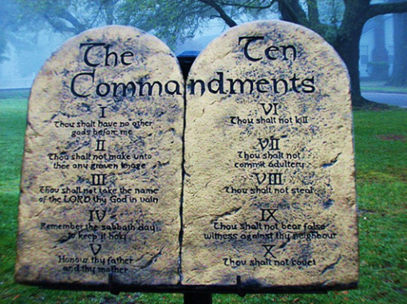
‘Do not kill’ (Exodus)

This links to the fact that many Jews believe that G-d is omniscient (all-knowing) and therefore knows everything we do. Therefore, G-d will judge all Jewish people on their actions.

Q1: What does this quote(s) tell Jewish people about G-d?

Q2: What influence might this have for Jews today? (think back to the environment topic to help you)


- G-d as forgiving and merciful
G-d is viewed as being merciful and forgiving due to his ability to forgive people of sins they may have committed. The Jewish festival of Yom Kippur is time for Jews to ask G-d for forgiveness of their sins. This shows that G-d is viewed as forgiving and merciful.
In one story, Moses asks G-d for forgiveness and G-d replies:
“I pardon you (of your sins), as you have asked” Numbers 14:19-20

Q1: What does this quote(s) tell Jewish people about G-d?

Q2: What influence might this have for Jews today? (think back to the environment topic to help you)

Reflection time
After learning about the different qualities of God for Jewish people. Which do you think is the most important for Jewish people and why?

Challenge! Which do you believe is the least important and why?

Main task 3
Complete the short exam style question to assess what you have learnt. Use the sentence starters to help you and the stuck box for ideas.
Explain two Jewish teachings about God. In your answer you should refer to scripture (5 mark)

SENTENCE STARTERS
One Jewish teaching about God is that God is… This is shown by…

Another Jewish teaching about God is that God is… This is shown by… In the Torah it says… This shows that…

Stuck? – you could include these keywords…
Judge, Forgiving, Mericful, One, Creator, Torah, Genesis, Exodus, Commandments, Moses, Creation.
Plenary
Write a tweet about what you have learnt today. Don’t forget to hashtag keywords
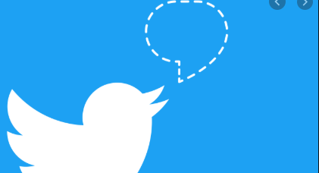

Lesson 3 – The covenant with Abraham
Lesson objectives
- Understand who Abraham was
- Explain the significance of his covenant with God for Jewish people today

Starter
Settler (think back to the previous lesson) – answer the exam style question
‘Give two qualities of G-d for Jewish people’ [2 marks]
- ___________________________________________
- ___________________________________________
Don’t forget to self-mark after!

Starter task – look at the following image and write down ideas about what you think is happening (don’t worry if you are not sure - just have a guess!)
Who?

What?

Why?

When?

How?

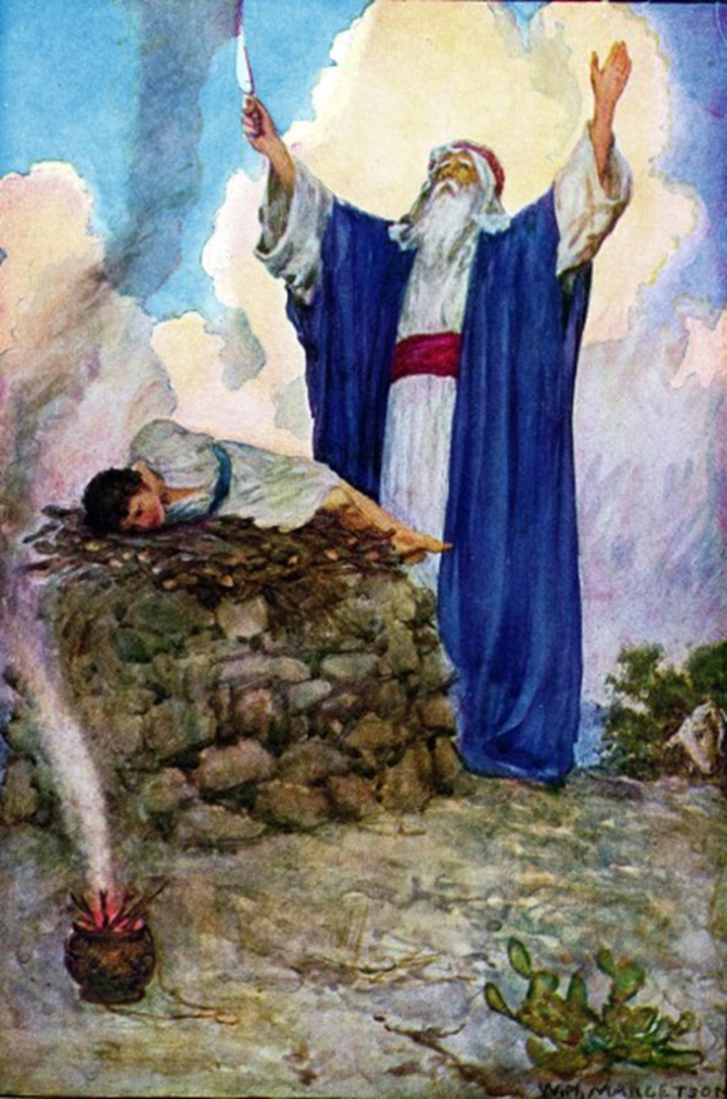

Main task 1 – who was Abraham?
What is meant by covenant? - The Abrahamic Covenant is the covenant (agreement or promise) made between God and Abraham. God wanted the Jews to live their lives in such a way as to show the world that God actually was the one and only all-powerful God, whom people should follow and worship.
Who is Abraham?
The history of the Jewish people begins in the Middle East when God promised a leader called Abram that he would be the father of a great people if he did as God told him. He lived in a time where people worshipped many Gods. The story of Abraham and his children is found in the book of Genesis, chapter 11. At the beginning of Genesis chapter 12, God asked Abram to leave his home and country and he makes Abram three promises: the promise of a relationship with God, children, and land. Abraham and his wife Sarah, were too old to have children naturally. They will have to leave their homeland and they don't even know who this God is! But the amazing fact about Abraham is that he does what he is asked.
Read Genesis 12 below and answer the questions
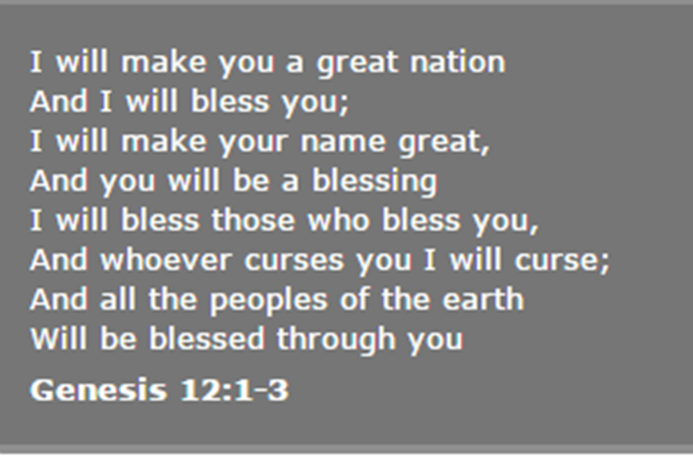

Q1: What does Genesis 12 tell you?

Q2: Explain how you think Abraham felt when he heard this

Challenge! Do you think Abraham was wrong to leave his hometown? Explain why with two reasons

Main task 2 – Abrahams sacrifice
Abraham was tested several times by God to see if he was truly obedient. One of the greatest tests was when Abraham was asked to sacrifice his son Isaac.
- Watch the YouTube clip to help you understand what happened: https://www.youtube.com/watch?v=6s9ldacroHM
- Read the story in Genesis below

Some time later God tested Abraham. He said to him, “Abraham!” “Here I am,” he replied.
Then God said, “Take your son, your only son, whom you love—Isaac—and go to the region of Moriah. Sacrifice him there as a burnt offering on a mountain I will show you.” Early the next morning Abraham got up and loaded his donkey. He took with him two of his servants and his son Isaac. When he had cut enough wood for the burnt offering, he set out for the place God had told him about. On the third day, Abraham looked up and saw the place in the distance. He said to his servants, “Stay here with the donkey while I and the boy go over there. We will worship and then we will come back to you.” Abraham took the wood for the burnt offering and placed it on his son Isaac, and he himself carried the fire and the knife. As the two of them went on together, Isaac spoke up and said to his father Abraham, “Father?”
“Yes, my son?” Abraham replied. “The fire and wood are here,” Isaac said, “but where is the lamb for the burnt offering?” Abraham answered, “God himself will provide the lamb for the burnt offering, my son.” And the two of them went on together. When they reached the place, God had told him about; Abraham built an altar there and arranged the wood on it. He bound his son Isaac and laid him on the altar, on top of the wood. Then he reached out his hand and took the knife to slay his son. But the angel of the Lord called out to him from heaven, “Abraham! Abraham!” “Here I am,” he replied. “Do not lay a hand on the boy,” he said. “Do not do anything to him. Now I know that you fear God, because you have not withheld from me your son, your only son.” Abraham looked up and there in a thicket he saw a ram[a] caught by its horns. He went over and took the ram and sacrificed it as a burnt offering instead of his son. So Abraham called that place The Lord Will Provide. And to this day, it is said, “On the mountain of the Lord it will be provided.” The angel of the Lord called to Abraham from heaven a second time and said, “I swear by myself, declares the Lord, that because you have done this and have not withheld your son, your only son, I will surely bless you and make your descendants as numerous as the stars in the sky and as the sand on the seashore. Your descendants will take possession of the cities of their enemies, and through your offspring all nations on earth will be blessed, because you have obeyed me.”
Now answer the questions below
- How do you believe Abraham felt and why?
- What does Isaac think will be sacrificed?
- How do you believe Isaac felt when he learnt he was to be the sacrifice?
- What does God reward Abraham with?

Main task 3 – the influence of the Covenant for Jews today
The Abrahamic Covenant is the covenant (agreement or promise) made between God and Abraham. God wanted the Jews to live their lives in such a way as to show the world that God actually was the one and only all-powerful God, whom people should follow and worship.
God promises to:
- Make of Abraham a ‘great nation’; guide Abraham
- Make Abraham fruitful (give him lots of descendants/children)
- Give Abraham and his descendants a land to call their own. This is known as the Promised Land (the land of milk and honey). “The whole land of Canaan, where you are now an alien, I will give as an everlasting possession to you and your descendants after you; and I will be their God”
Abraham promises to:
- Circumcise as a sign of the covenant. All boys, aged 8 days old, must be circumcised
- Follow the mitzvot given to Abraham

Some Jews today will follow the Mizvot in their daily lives. Research the Mitzvot here: https://www.bbc.co.uk/bitesize/guides/zfwr97h/revision/3 and complete the table below with your research

Positive and negative Mizvot | Ritual Mizvot
Moral Mizvot | Constant Mizvot

Plenary
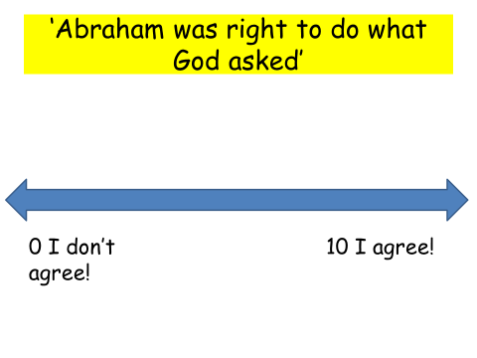
Where would you place yourself on the line and why?

Lesson 4 – Shabbat
Lesson objectives
- Understand what Shabbat is.
- Explain how Shabbat is celebrated, and its importance for Jews.

Starter
Settler – you have 5 minutes to create a mind map about what you learnt last lesson WITHOUT looking at your notes
Covenant with Abraham

Starter task -
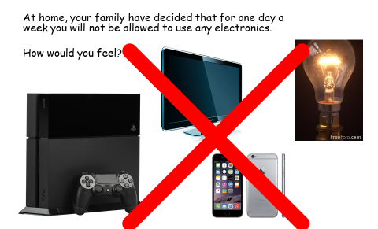
How would you feel and why?

Main task 1 – what is Shabbat?
Fill in the missing words
- Shabbat is a Hebrew word meaning S……………… The Shabbat is a day of r……………, no work is allowed during the Shabbat.
- The Shabbat is a special day for J…………………… families. It starts on a F………………, at sunset. The house is c………………….. and special food is prepared beforehand as no work is allowed.
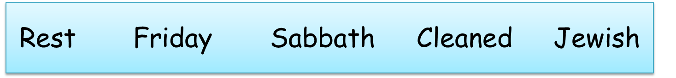
Watch the following YouTube clip and write down 5 things you can see happening
https://www.youtube.com/watch?v=ucEIPOxR-bs
1)
2)
3)
4)
5)

These are the things Jewish people are allowed to do and NOT to do on Shabbat
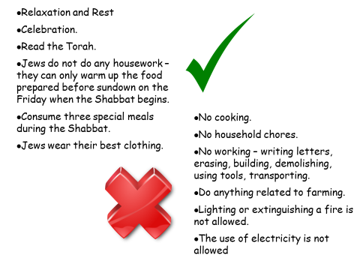
- Make a list of the things you would not be able to do if you observed Shabbat

- How would this make you feel and why?

- What do you think you would concentrate on more and why?

Main task 2 – Creating a Shabbat leaflet
Using what you have learnt so far and the website link below create a leaflet about Shabbat
https://www.bbc.co.uk/bitesize/guides/zbm8jty/revision/3
Success criteria
- Why Shabbat is celebrated
- Why Shabbat is important for Jews
- How it is celebrated at home
- How it is celebrated at the Synagogue
- The Havdalah service

If you are stuck use the leaflet template on the next page to help you

Challenge! Send a copy/photograph of your leaflet to a friend and get them to peer assess it.
Give it a STAR
S – SUCCESS
T – TARGET
AR – ACTION REQUIRED

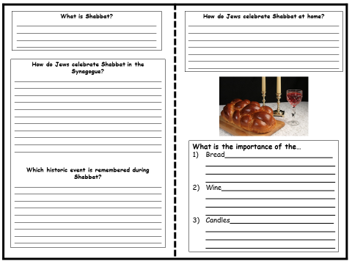

Plenary
Complete the short exam style questions to assess your learning

‘Name two items Jews use on Shabbat’ [2 marks]
- _________________________________
- _________________________________

‘Explain two contrasting ways that Jewish families celebrate Shabbat’ [4 marks]

SENTENCE STARTERS
One way that Jewish families celebrate Shabbat is… This is important as…
Another way that Jewish families celebrate Shabbat is… This is important as…

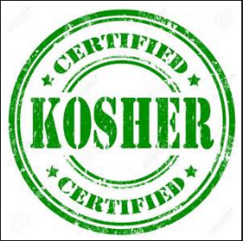
Lesson 5 - Keeping Kosher

Learning objectives
- To understand what Kosher means
- To explain which foods are Kosher and why
- To evaluate the importance of keeping Kosher for Jewish people

Starter
Settler (think back to last lesson) – Give three reasons why Shabbat is important for Jews
1)
2)
3)

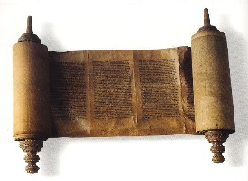
Starter task
Kosher in Hebrew means ‘clean’ or ‘fit’

What is Kosher?
Kosher in Hebrew means ‘clean’ or ‘fit’ and describes food that is okay to eat for Jewish people. In Judaism there are many food rules that must be followed, and they are found in the Torah (Jewish Holy Book).

The Torah tells Jewish people that they may only eat the meat of land animals that;
1. Have split hooves


2. Chew their own cud (grass)


3. Kosher fish and other sea creatures must have fins & scales. They must not have a hard shell.

Crab
Cod


4. Kosher birds or poultry must not be a bird of prey (hunt small animals), and they must only eat grain (e.g. corn)


Task: Can you name 5 kosher foods?

Main task 1
What makes Kosher food, Kosher?
- All animals must be killed as painlessly as possible. This is because it is against the Jewish law to cause pain to living things.
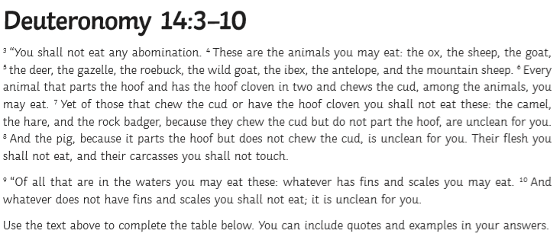
- Meat and dairy must also NOT be mixed together, as it says in the Torah 3 times to not do it.
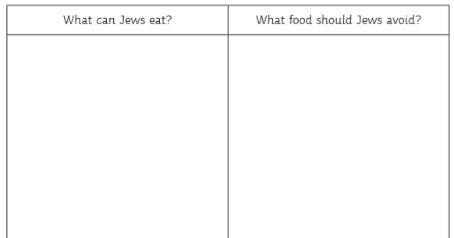
- Main task 2
Why is keeping Kosher important for Jewish people?
Task: Read through the reasons why keeping Kosher is important. Then decide which reason you think is the most important for Jewish people, and label it as number 1. Order the rest from 1 (most important) to 4 (the least important).
- Keeping Kosher has been a practice within Judaism for thousands of years. For example, Jews were once forced to eat pork by the Syrian leaders. Some Jews chose to die rather than do this, this shows their dedication to Jewish laws.
- Kosher is a way of welcoming the holiness of Judaism into their daily lives. At each meal, Jews remember the high standards of Jewish living and behaviour. Jews believe that they gain strength and depth through the regular practice of Kosher.
- Obeying Kosher law offers many health benefits for Jewish people. For example, the mixing of meat and dairy is said to help with indigestion.
- Keeping kosher is an act of faith and obedience to God. Jews may not understand why God has given these rules, but he has done so, and he is to be trusted and obeyed. The fact that these rules are found in the Torah shows Jews that they must be followed.
I have chosen number one as the most important reason for keeping Kosher. This is because….
Challenge: I have chosen number 4 as the least most important reason for keeping Kosher. This is because…

PLENARY TASK – Are these menus Kosher?
Menu 1
Starter: Mozzarella and tomato salad
Main: Cheeseburger and chips
Dessert: Chocolate fudge cake

This menu is/is not Kosher.
This is because _________
__________________________________________________
Menu 3
Starter: Breaded garlic mushrooms
Main: Bacon and cheese pie
Dessert: Strawberry cheesecake

Menu 2
Starter: Tomato and basil soup
Main: Lamb shank, potatoes and salad
Dessert: Sticky toffee pudding

This menu is/is not Kosher.
This is because _________
________________________________________________
This menu is/is not Kosher.
This is because _________
________________________________________________

Don’t forget to self mark!

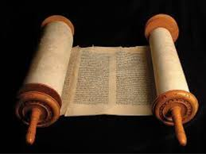
Lesson 6 - The Torah
Learning objectives
- Explain the importance of the Torah to Jewish people
- Evaluate the importance of the Torah in everyday Jewish life.

Starter
Settler (think back to last lesson) – Create a 5 question true or false about Kosher food

Starter task – what is a book that is important to you and why?
The Torah is the first part of the Jewish Bible meaning ‘instruction’ or ‘Law’

Keywords:
- Parchment: type of paper the Torah is written on
- Torah Scrolls: Jewish scriptures
- Ark: Chest where Scrolls are kept
- Yad: pointer used to read the Torah

What is the Torah?
- The Torah is the sacred text of the Jewish people.
- Traditional Jewish people believe that God told Moses all of the Torah on Mount Sinai, and that Moses wrote down his exact words.
- Almost all Jewish people believe that God gave Moses the Ten Commandments.

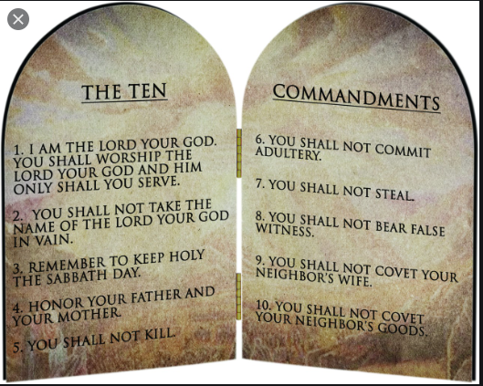

Main task 1
https://www.truetube.co.uk/film/holy-books-torah
Watch the link and write down 5 things you learn about the Torah.

Why is the Torah so important to Jews?
Complete the Task AND Challenge.
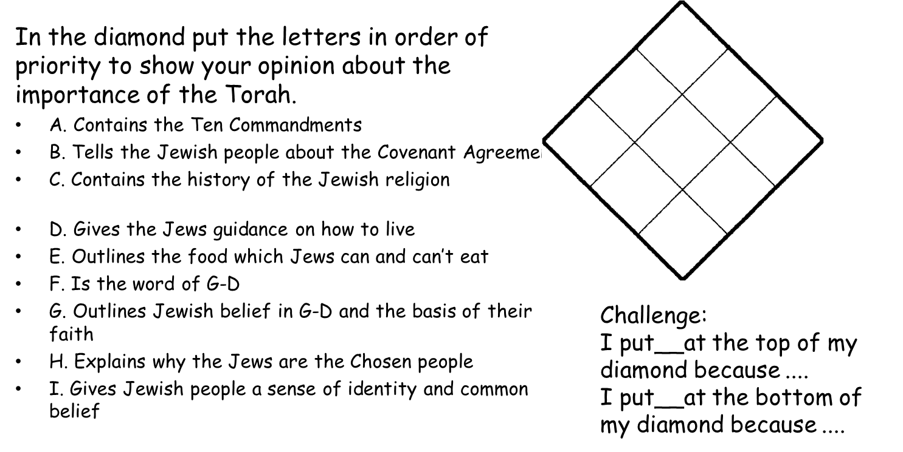

How do Jewish people show respect to the Torah?
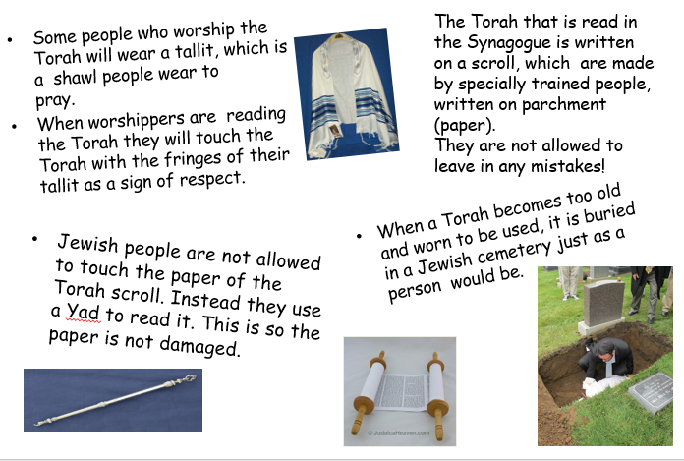
Task:
Are there any similarities or differences to how you show importance to your holy book?
*if you do not have a holy book, use the Christian Bible as an example.

Similarities | Differences

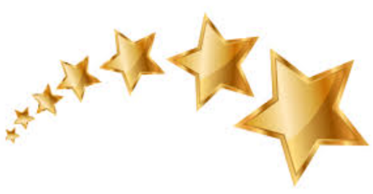
STAR QUESTION: (Use the sentence starters below to help you!)
STAR TASK
“The Torah is still important for Jewish people in modern day” (6 marks)
Evaluate the statement.

Somebody may agree that the Torah is still important for Jewish people in modern day because…
(hint: think about the 10 commandments, how Jews treat the Torah and the kosher rules from your previous lesson!)
Somebody may disagree and argue that the Torah is no longer important for Jewish people because…
(hint: Think about if the Torah rules are relevant to modern day and whether they are easy to follow? Is it easy to show respect to the Torah?)=
A Jewish person would argue that the Torah is still important because…
In my opinion…

**You must write/type your answer on a separate piece of paper and attach here.

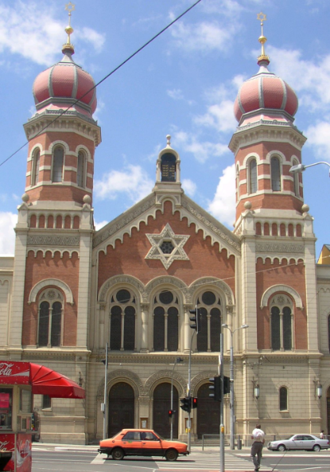
Lesson 7 - The Synagogue
- Lesson objectives
- Explain features of the Synagogue and their importance.

Starter
Settler – Compare the Torah to the Bible. What is similar and what is different?

Starter task – What building do you consider most important to you and why?

Main task 1
Synagogue comes from the Hebrew word that means “House of Assembly”

The synagogue is the Jewish place of worship and is called the ‘House of Assembly’ because the synagogue is used not just as a house of prayer, but as somewhere to go and study and a place to meet people as well.
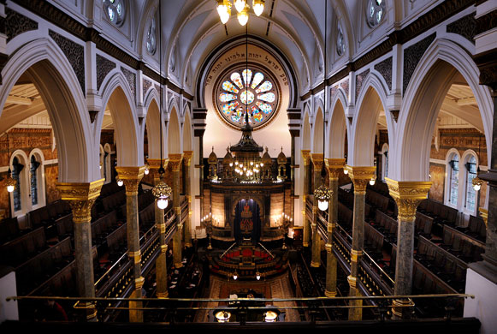
Every synagogue is different, just like every church, all synagogues look different on the inside and the outside. But they all have the same sort of layout.

Task:
https://www.youtube.com/watch?v=nwPti4ev2VY
Watch the video, write down 5 things you learn.

What can you find inside the Synagogue?
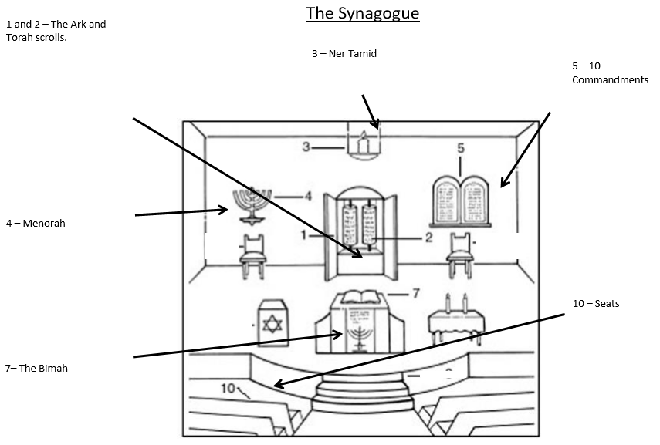

Task: Using the internet research and make notes on the different aspects of the Synagogue. Make your notes on below.
- The Ark (What is it? What is kept inside?)
- The Torah Scrolls (What is it? How is it kept?)
- Ner Tamid (What is it? Why is it always on?)
- Menorah (What is it? What does it represent?)
- 10 commandments (What are they? Where do Jews believe they came from?)
- The Gallery (Who sits there? Why?)
- The Bimah (What is it? What is done from there?)
- The Star of David (What is it? Why is it important to Jews, and therefore displayed in/outside the Synagogue?)
- The Siddur (What is it? When/where is it used?)
- The Tallit (What is it? Why is it worn?)

Plenary Task: Complete the sentences.
- I think the most important feature of the Synagogue is… because…
- The synagogue is similar to my place of worship because…

- The synagogue is different to my place of worship because...

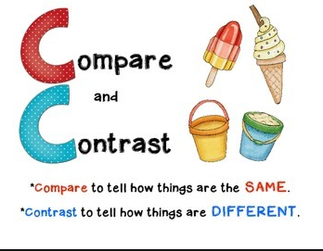

Lesson 8 – Rosh Hashanah

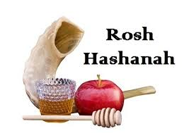
Learning objectives
- To know what Rosh Hashanah is.
- To understand why and how it is celebrated.
- To be able to reflect on the importance of Rosh Hashanah and it’s links to atonement.

Key Words:
Atonement. - Making up for something and asking for forgiveness
Repentance - Regretting the things you did wrong and wanting to put them right.

Starter
Settler – Which is the most important part of the Synagogue in your opinion?

Starter - What were your New Year’s resolutions? Write a list!
If you did not make any, ask your friends and family for theirs.

Main task
Rosh Hashanah
aka ‘The Head of the Year’

For Jewish people, the New Year is not on the 1st of January. Rosh Hashanah is the birthday of the world. During this festival Jews recall how God created the world in 6 days and rested on the seventh. Rosh Hashanah is a day of rest and a day for new beginnings.
Rosh Hashanah is also the start of the most thoughtful part of the Jewish year, which lasts for 10 days. These ten days are called the Days of Repentance. It is a time of reflection. It gives Jews a chance to think about the past year and how God will judge their behaviour.
Atonement and Forgiveness
An old Jewish legend says that on Rosh Hashanah three books are opened in heaven and the actions of everyone are recorded in them. They are then sealed by God. On judgement day, the books will be opened and everyone will have to account for the way they have lived. Because of this, it is very important that everyone seeks forgiveness on Rosh Hashanah while they still have the opportunity.
Questions:
- Summarise Rosh Hashanah in your own words.
Sentence Starters:
Rosh Hashanah marks the start of the Jewish New Year. It is a time where Jews…
Jews reflect upon…
There are many traditions such as...

- Why is it important to reflect on our behaviour?
It is important to reflect on our behaviour because…

Research Task:

Using google, research Rosh Hashanah in order to answer these questions:
- Name two ritual foods and explain why they are used.
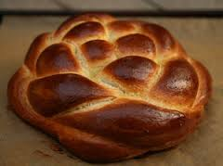
Two ritual foods are… they are used because…

- What must Jewish people do during Rosh Hashanah?
During Rosh Hashanah, Jews…

Create!
Create a Rosh Hashanah card which includes an explanation of why Jewish people celebrate it.
Challenge: ‘Shabbat is more important than Rosh Hashanah’ Do you agree?
Give two reasons to explain.

Plenary
Is the Jewish view of ‘NY resolutions’ the same or different to yours?
Use your starter to explain why.
The Jewish view of ‘NY resolutions’ is the same/different to my view because... For example I said that I thought... But they think...

Lesson 9 – Inspiring leaders

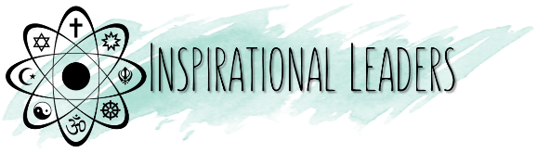
Sergey Brin: Overcoming Obstacles
Learning objectives
- To understand what anti-Semitism is and how it effected the Brin family
To reflect on the obstacles the Brin family faced and how they were overcome
To consider the setbacks we may experience in life and how we might overcome them
Key Word:
Anti-semitism - Hostility (opposition/aggression) toward Jews just because they are Jewish. E.G. people/teachings that proclaim the inferiority of Jews, or political efforts to isolate, oppress, or otherwise injure them. It may also include prejudiced or stereotyped views about Jews.

Main task
- Sergey Brin is a Jewish American computer scientist and Internet entrepreneur.
- Brin immigrated to the United States with his family from the Soviet Union at the age of 6.
- He earned his bachelor's degree at the University of Maryland and studied mathematics, as well as computer science.
- After graduation, he enrolled in Stanford University to acquire a PhD in computer science. There he met Larry Page, with whom he built a web search engine -
- Brin is the president of Google's parent company Alphabet Inc. As of June 2019, Brin is the 13th-richest person in the world, with an estimated net worth of US$50.1 billion.
- Sergey Brin was born in Moscow in 1973. However, his family left Russia in 1979.
- Sergey’s parents had been subject to anti-Semitism and believed that a new life in America would give Sergey a brighter, better future.

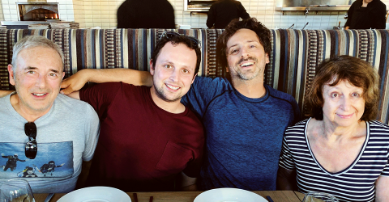
Sergey’s mother
Genia
Sergey’s father
Michael

In the 1960-1970s…

In the U.S.S.R. the Communist Party had stopped Jews from achieving upper professional jobs by denying them entry to some universities and university courses.
- Michael was able to study mathematics. But gaining acceptance to the math department at Moscow State was extremely difficult. There were entrance exams and Jews were tested in different rooms from other applicants—morbidly nicknamed “gas chambers”—and graded more harshly.
- With help from a family friend, Michael was accepted and in 1970 graduated with an honours degree. However, “…nobody would even consider me for graduate school because I was Jewish. That was normal.”
Task:
Read the article on the next page, and then answer the questions below.
1) Why do you think Sergey’s family wanted to leave Russia?
I think Sergey’s family wanted to leave Russia because…
2) How do you think Sergey’s father Michael may have inspired him?
I think Sergey’s father may have inspired him by…
3) What do you think might have happened if the family had stayed in Moscow?
If the Brin family had stayed in Moscow, I think…
4) What do you think is the most important lesson we can learn from Sergey’s family’s experiences?
I think the most important lesson we can learn from Sergey’s family’s
experiences is…

The Story of Sergey Brin
BY MARK MALSEED
“I’ve known for a long time that my father wasn’t able to pursue the career he wanted,” Sergey tells me. As a young boy, though, Sergey had only a vague awareness of why his family wanted to leave their native Russia, but he sensed, early on, all of the things that he wasn’t: He wasn’t Russian. He wasn’t welcome in his own country. He wasn’t going to get a fair chance in advancing through its schools. Further complicating his understanding of his Jewish identity was the fact that, under the atheist Soviet regime, there were few religious or cultural models of what being Jewish was. The negatives were all he had.

Sergey is too young to remember the day, in the summer of 1977, when his father came home and announced that it was time for the family to emigrate. “We cannot stay here any more,” he told his wife and mother.

The couple knew, of course, the dangers of applying for an exit visa. They could easily end up being refused, fired from their jobs and unable to find work, shunned, in everlasting limbo. Nobody had promised Michael a job abroad but he was confident he could find work in the West. Genia, however, was unconvinced. They had lived in Moscow their entire lives. They had decent jobs and a young son. Was it worth it to try to leave? “I didn’t want to go,” she says. “It took a while for me and his mother to agree. I had a lot more attachments.” It was up to Michael to do the convincing. “I was the only one in the family who decided it was really important to leave—not in some distant future,” he says.

The Brins’ story provides me with a clue to the origins of Sergey’s entrepreneurial instincts. His parents, academics through and through, deny any role in forming their son’s great business intelligence—“He did not learn it from us, absolutely not our area,” Michael says. Yet Sergey’s willingness to take risks, his sense of whom to trust and ask for help, his vision to see something better and the conviction to go after it—these traits are evident in much of what Michael Brin did.

For many Soviet Jews, exit visas never came. But, in May 1979, the Brins were granted papers to leave the U.S.S.R. “We hoped it would happen,” Genia says, “but we were completely surprised by how quickly it did.” The timing was lucky: They were among the last Jews allowed to leave until the Gorbachev era in 1985.

When the family finally landed in America on October 25, they were met at New York’s Kennedy Airport by friends from Moscow. Sergey’s first memory of the United States was of sitting in the backseat of the car, amazed at all the giant cars on the highway as their hosts drove them home to Long Island.

Sergey attended Hebrew school at Mishkan Torah for the better part of three years but hated the language instruction and everything else, too. “He was teased there by other kids and he begged us not to send him any more,” his mother remembers. “Eventually, it worked.”

Sergey then attended Eleanor Roosevelt High School, a large public school in Greenbelt. With hard work and determination, he completed his studies in three years, amassing a year’s worth of college credits that would enable him to finish college in three years as well. At only 15 years old, Sergey enrolled in the University of Maryland and majored in mathematics and computer science. He graduated near the top of his class.

When he won a prestigious National Science Foundation scholarship for graduate school, he insisted on Stanford. Aside from the physical beauty of Stanford’s campus, Sergey knew the school’s reputation for supporting high-tech entrepreneurs. At the time, though, his focus was squarely on getting his doctorate.

However, what came next is Google legend. In the spring of 1995, during a prospective student weekend, Sergey met an opinionated computer science student from the University of Michigan named Larry Page.

Create!
Create a snakes and ladders game – you can use the different templates on the following pages if needed.

- Attached to the snakes need to be examples of set backs that the Brin family experienced or may have experienced.
- Attached to the ladders need to be examples of achievement, success or overcoming obstacles inspired by the Brin family.

Final Task:
What could be some of the setbacks we might experience in life?
Some of the setbacks we might experience is…
How could we overcome these?
We could overcome them by…

Create!
Create a snakes and ladders game – you can use the different templates on the following pages if needed.

- Attached to the snakes need to be examples of set backs that the Brin family experienced or may have experienced.
- Attached to the ladders need to be examples of achievement, success or overcoming obstacles inspired by the Brin family.

E.G.



Michael was forced to abandon his dream of becoming an astronomer -Universities barred him from the course as he was Jewish
The Brin family receive their visa to America!

25 | 26 | 27 | 28 | 29 | 30
24 | 23 | 22 | 21 | 20 | 19
13 | 14 | 15 | 16 | 17 | 18
12 | 11 | 10 | 9 | 8 | 7
1 | 2 | 3 | 4 | 5 | 6

25 | 26 | 27 |   28 | 29 | 30
24 |   23 | 22 | 21 |   20 | 19
  13 | 14 | 15 |   16 | 17 | 18
12 | 11 | 10 | 9 |   8 | 7
  1 | 2 | 3 | 4 | 5 | 6

Answers for self-marking
Lesson 1 – Introduction
Starter task
Q1 – 4000 years
Q2 – One
Q3 – Synagogue
Q4 – United States and Israel
Q5 – 14 million
Q6 – Torah
Q7 – Abraham
Main task 2
- What are the two main Jewish groups in the UK? – Orthodox and Reform
- What must each Jew decide? – by their individual interpretation of the Torah
- How do Orthodox Jews live? – Closely to the Torah as possible
- How many of the mitzvot will Orthodox Jews try to observe (follow)? 613
- What will Orthodox Jews spend their lives devoted to? Devoted to study and practice of the Torah
- Which laws of the Torah are binding for Reform Jews? Only the ethical laws are binding
- Why are some laws not necessary in Reform Judaism? It needs to adapt with the changing world and times
- What does interpretation rely on? Individual reasoning and conscience
- What are ‘secular’ Jews? Jews who do not believe in God but are born into a Jewish family

Lesson 3 – Covenant with Abraham
Settler
One mark for each correct answer out of the two
- G-d as one
- G-d as the creator
- G-d as the judge
- G-d as forgiving and merciful

Lesson 4 – Shabbat
Plenary
‘Name two items Jews use on Shabbat’ [2 marks]
- Candles
- Bread
- Wine
- Prayer book
- Torah
‘Explain two contrasting ways that Jewish families celebrate Shabbat’ [4 marks]
- They go to the Synagogue (what do they do? Example needed)
- Any example of how the wine, bread or candles are used.
- The Shabbat meal (what is done and why)
- Havdalah service (what is done and why)

Lesson 5 – Kosher
Plenary
- Menu 1 – NOT KOSHER because of cheese and burger (mixing meat)
- Menu 2 – KOSHER
- Menu 3 – NOT KOSHER because of mixing meat and pork (non kosher food)

