Buddhism home learning
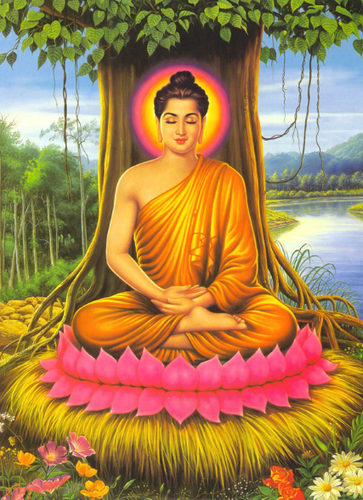
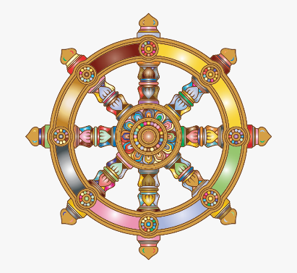

Enjoy learning about Buddhism as you work through this booklet. There will be opportunities for you to self-assess your work. If you have any questions please email your teacher.

This is a checklist of all the topics. Rate yourself at the START of the topic. Then come back to it at the end and rate yourself again.
RED – I know nothing about this topic
AMBER – I know what this keyword(s) mean and I could explain why it is important for Buddhists
GREEN – I am confident with this topic. I could explain in detail using examples why it is important for Buddhists. I could also give different viewpoints about opinions about it.
At the start of this topic I am…(don’t worry if this is mostly red!)
 | RED | AMBER | GREEN
The early life of the Buddha
Enlightenment
4 Noble Truths
Following the Eightfold Path
5 Moral Precepts
Karma and reincarnation
Meditation
What can Buddhists learn from the life of the Buddha?
Inspiring Buddhist leader: Thich Nhat Hanh

At the end of this topic I am…
 | RED | AMBER | GREEN
The early life of the Buddha
Enlightenment
4 Noble Truths
Following the Eightfold Path
5 Moral Precepts
Karma and reincarnation
Meditation
What can Buddhists learn from the life of the Buddha?
Inspiring Buddhist leader: Thich Nhat Hanh

Keywords
Fill in the missing words to learn the keywords for Buddhism

- 4 Noble truths - An important part of the Buddha’s teachings explaining the t………………. about existence. These include: suffering, the cause of suffering, the end of suffering, the path to the end of suffering.
- 5 Precepts - 5 basic guidelines that Buddhists follow to guide their actions and b……………………………..
- Anicca - Impermanence. The belief that nothing is p…………………………….
- Buddha - means `an enlightened person’. It also refers to the man who started the r……………………. of Buddhism.
- Chanting - Singing or r…………………… repetition of a word, prayer or sound.
- Concentration - Focusing one’s a…………………………; an important part of meditation and mindfulness of breathing.
- Consciousness - The state of being a……………. of something/your surroundings before or without perception.
- Craving - The ongoing state of d…………… which causes suffering; grasping at things we enjoy/want.
- Dhamma (Dharma) - The teachings of the B…………..; these are the ultimate truth
- Dhammapada - A source of w…………………….. and authority; part of the Pali Canon that includes some of the most famous teachings of the Buddha, including the Eightfold Path.
- Dukkha - Suffering. Belief that all life includes s…………………………… and unsatisfactoriness
- Eightfold path - The fourth Noble Truth. Known as ‘The M……………….. Way,’ it includes the way to wisdom; mental training and the way of morality. Eight stages to be practised by Buddhists.
- Enlightenment - A state of wisdom that enables total clarity and understanding of the truths of existence; achieving Enlightenment allows being freed from the c…………….. of rebirth.
- Karma - Literally 'action.’ The belief in cause and effect, intentions and actions will affect the f…………………...
- Meditation - A s…………………… experience that opens a person up to the highest state of consciousness.
- Nirvana - The belief that individuals can achieve a state of p…………………… peace where they experience liberation from the cycle of birth, death and rebirth.
- Rebirth - This refers to the belief that when a being d…….. they are reborn.
- Shrine - A room or part of a room which contains a Buddha statue, c………………….., an incense burner and sometimes other offerings.
- Temple - A structure/b………………………… for religious or spiritual activities, such as meditation. Will usually contain a shrine

MISSING WORDS – Suffering, Future, Truth, Dies, Desire, Rhythmic, Cycle, Attention, Building, Behaviour, Spiritual, Aware, Perfect, Buddha, Religion, Candles, Middle, Permanent, Wisdom.
Lesson 1 – Introduction to Buddhism

Lesson objectives
- Understand why it is important to learn about Buddhism
- Explain the basic beliefs and practices of Buddhism
- Compare the different schools of Buddhism

Starter
Use the following website to find out some facts about Buddhism:
https://www.history.com/topics/religion/buddhism

- Which country was Buddhism founded in?
- How many years ago was Buddhism founded?
- Approximately how many followers does Buddhism have?
- What was the Buddha’s original name?
- What does the word Buddha mean?
- Name 3 Buddhist symbols
- True or false? Buddhists don’t acknowledge a supreme deity (God)
Don’t forget to self-assess your answers!

Why do we study Buddhism?
- According to the 2011 census there are 178,000 Buddhists in Britain.
- Buddhism focuses on values such as happiness – something everyone can relate to!
- Buddhism teaches us how to overcome suffering and cravings. Something we could all benefit from.
- It is important that we have an understanding of ALL religions.

Main task 1
Watch the YouTube video below and create a spider diagram with new information you learn about Buddhism
https://www.youtube.com/watch?v=WawmRP0frhY

What I learnt about Buddhism

Extra challenge! – Create an information leaflet about the basics of Buddhism for a year 6 student to learn about the religion.

Main task 2
Just like in other religions, all Buddhists are not exactly the same. They have different denominations or ‘schools’ which all have different practices and beliefs. Read the information about the main 2 Buddhist schools and complete the tasks after.

- Mahayana Buddhism
Strongest in Tibet, China, Taiwan, Japan, Korea, and Mongolia and is the largest major tradition of Buddhism existing today (around 53%). Mahayana Buddhists believe they can achieve enlightenment through following the teachings of the Buddha. The goal of a Mahayana Buddhist may be to become a Bodhisattva and this is achieved through the Six Perfections. Compassion is very important in Mahayana Buddhism. Therefore, Bodhisattvas choose to stay in the cycle of samsara to help others to achieve enlightenment as well as themselves.

This is a key difference between Theravada and Mahayana Buddhists. Whereas Theravada Buddhists strive to become Arhats and gain freedom from the cycle of samsara, Mahayana Buddhists may choose to stay in the cycle of samsara out of compassion for others.

- Theravada Buddhism
Theravada Buddhism is strongest in Sri Lanka, Cambodia, Thailand, Laos and Burma (Myanmar) and makes up approximately 15% of the Buddhist population. It is sometimes called 'Southern Buddhism'. Theravada Buddhism is older and the more conservative of the two main divisions of Buddhism and is often referred to as the ‘traditions of the elders’. Many Theravada Buddhists follow the teachings of the Buddha exactly, and many of them are monks or nuns.
Theravada Buddhists strive to be Arhats. Arhats are perfected people who have gained true insight into the nature of reality. This means they have followed the Noble Eightfold Path to ‘blow out’ the three fires of greed, hatred and ignorance and have become enlightened. In Buddhism, enlightenment leads to Nirvana, which means freedom from the cycle of rebirth (samsara). Consequently, they will no longer be reborn through samsara.

Task
 | What countries are they strongest in? | What percentage of the Buddhist population does it make up? | What do they believe about following the Buddha’s teachings? | What do they believe about Samsara (the cycle of re-birth)?
Mahayana Buddhism
Theravada Buddhism
Complete this table to consolidate what you have just read

Extra challenge! Compare these Buddhist schools to another religion of your choice. For example Catholics and Protestants or Reform and Orthodox Judaism

Plenary
‘All Buddhists should have the same beliefs about Samsara’

What is your opinion about this? Explain with two reasons.

Lesson 2 – The Early life of the Buddha

Lesson objectives
- Understand who Siddhartha was
- Explain the events and impact of Siddhartha’s early life

Settler
Think back to last lesson and create a quiz true or false quiz about the basics of Buddhism

Starter
Think back in to when you were a small child. Can you think of the first time that you became aware of the following things?
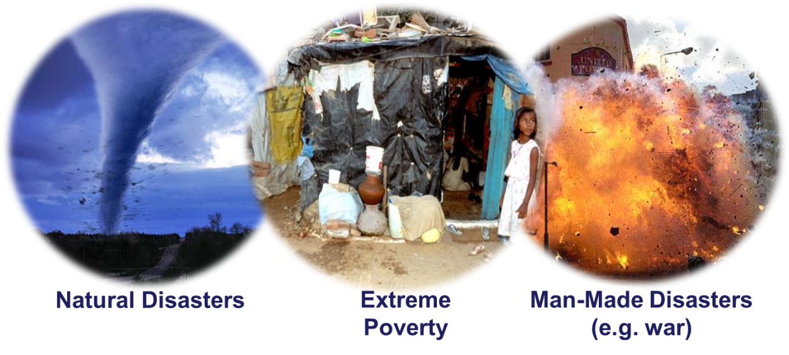

Question – Explain how you felt when you became aware of these things for the first time. If you cannot remember, try to think of the feelings you or other people might have had.

Main task
You are now going to learn about Siddhartha early life and the impact this had on him.
Watch the YouTube clip below and write down the 5 key moments in Siddhartha’s life https://www.youtube.com/watch?v=nsN7NLs-0jI

1)
2)
3)
4)
5)

Extra challenge – Which event do you believe had the greatest impact on Siddhartha and why?

Think back to your starter task – how did they link to Siddharthas life? (Hint: think about what Siddhartha saw when he left the palace)

Main task 2
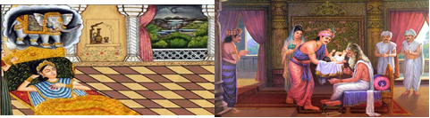
You are going to create a storyboard about the early life of the Buddha. Fill in each part with information based on the picture. Some of them are already filled in to give an idea of how much to write.
- Warning from a wise man

- Siddhartha’s birth

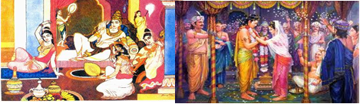

3) Life at the palace
His life at the palace was full of luxury and comfort. He was never allowed to see the outside world and was protected from seeing any suffering. For example, flower arrangements were never allowed to die, they were always replaced.

4) Marriage

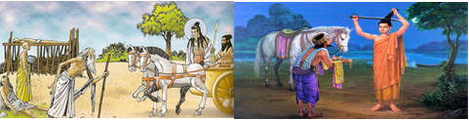
5) The 4 sights

6) Decision to leave the palace
He decided to leave behind his family, his life of comfort and fled the palace. He shaved his head and became a holy man. He spent time thinking about the cause of suffering in the world.

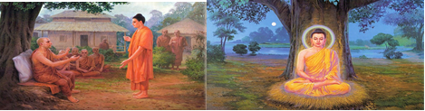
8) Meditation under the Bodhi tree

7) Meeting the monks
He met a group of monks who told him that he should only eat the smallest amount of food to find the answer to suffering. But he became ill and decided that was not the way.

Stuck words: Family, Palace, Buddha, Four, See, Happy, India, Sick, Food, Dreams, Suffering, Dead, Meditated, Die, Prince, King, Answer, Old, Allowed, Married, Holy, Hair, Not, World, Left.

Extra challenge! Do you think Siddhartha Gautama should have stayed at home and looked after his family instead of leaving the palace? Explain your answer.

Plenary
Complete the short answer questions to assess your learning
- What did Siddhartha spend a lot of time thinking about when he left the palace? [1 mark]
- The universe b) God c) Suffering d) Hunger

- What was always replaced in the palace so that Siddhartha never saw suffering? [1 mark]
- Clothing b) Flowers c) Money d) Food

- Name two of the 4 sights that Siddhartha saw [2 marks]
- ___________________________________
- ___________________________________

Don’t forget to self-mark your answers

Lesson 3 – Enlightenment

Learning objectives
- Understand what is meant by the term Enlightenment
- Explain how Siddhartha became enlightened
- To consider if we think there can ever be a middle way

Settler
Think back to last lesson and answer the following question…
Which of the 4 sights do you think had the biggest impact on Siddhartha and why? (hint: which one do you think inspired him to try and find the cause and solution to suffering?)

Starter
Unscramble the definition to find out what enlightenment means.
Don’t forget to self-mark after!

Enlightenment manes to konw the tturh, tougrhh matidetoin, Bishuddts try to fnid out the tturh aobut the urinvese. Wehn a Bishuddt has avieched enlightenment tehy wlil raceh Nirvana (release from the cycle of reincarnation).

Write it unscrambled here:

Main task 1
Look at each picture and write down all the things you can in the painting – you only have a minute for each!
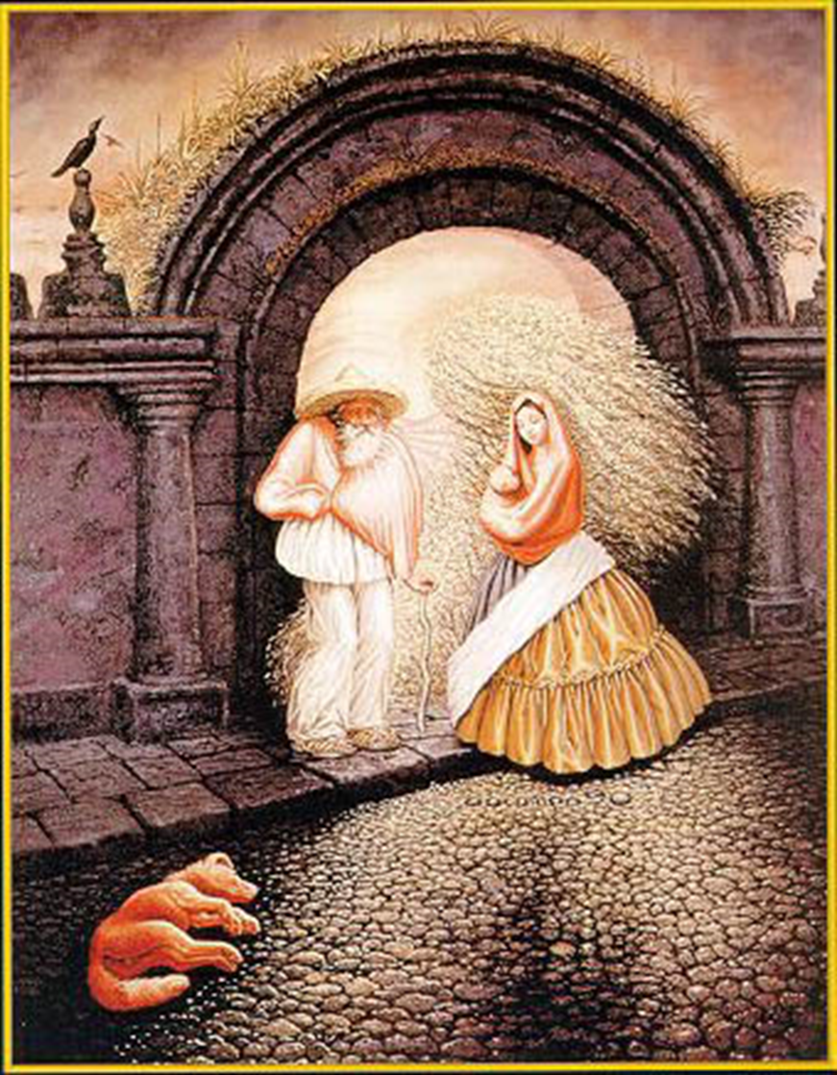
What can you see?
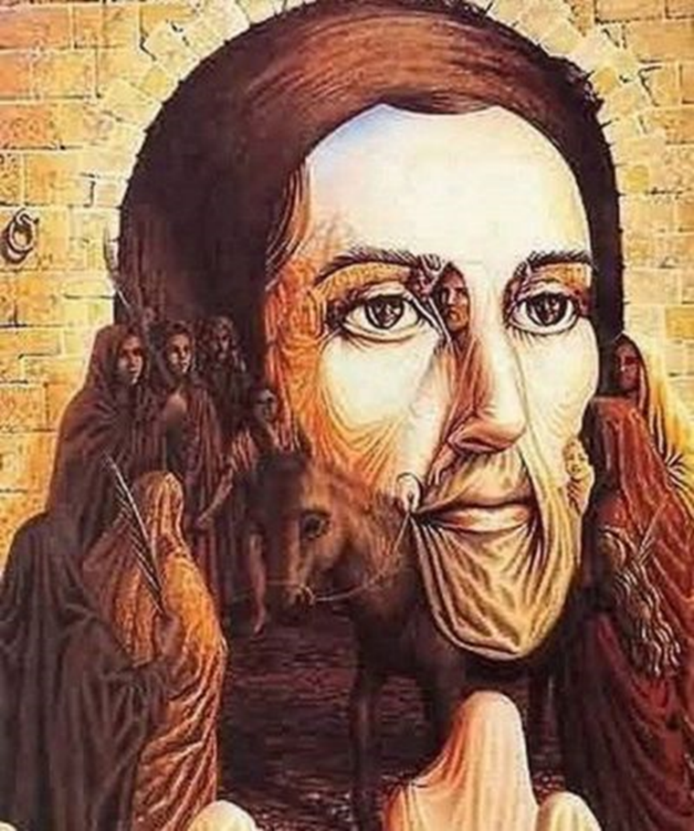
What can you see?

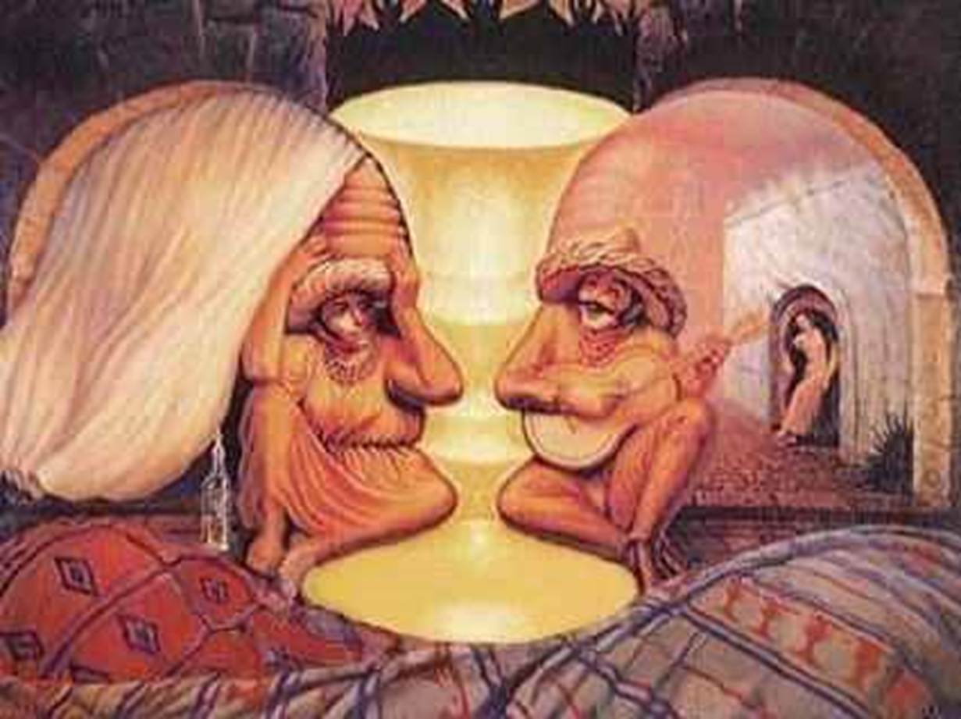
What can you see?

Question
How would you describe the feelings you had when you suddenly saw a face or something you hadn’t seen before in one of the illusion pictures?

Today you are learning in more detail what Siddhartha did after he saw the 4 sights
A way to imagine how enlightenment would feel is to remember how you felt when you saw the illusion pictures. At first you might not have noticed all of faces in the pictures. But then you recognised and understood how the picture had been created! For a Buddhist, enlightenment is the same – suddenly you realise how to overcome suffering, and you understand everything, and you feel completely happy.
Main task 2 – How did the Siddhartha become enlightened?
Watch the short YouTube clip and write a summary of how Siddhartha became enlightened
https://www.youtube.com/watch?v=nVKK-WVW2uw
SENTENCE STARTERS TO HELP YOU
After Siddhartha saw the 4 sights he…

He sat under the…

Siddharta became enlightened when…

After the Buddha had become enlightened and had learnt how to overcome suffering, what did he tell people to do, so that they could overcome suffering as well?
The Buddha’s solution for enlightenment
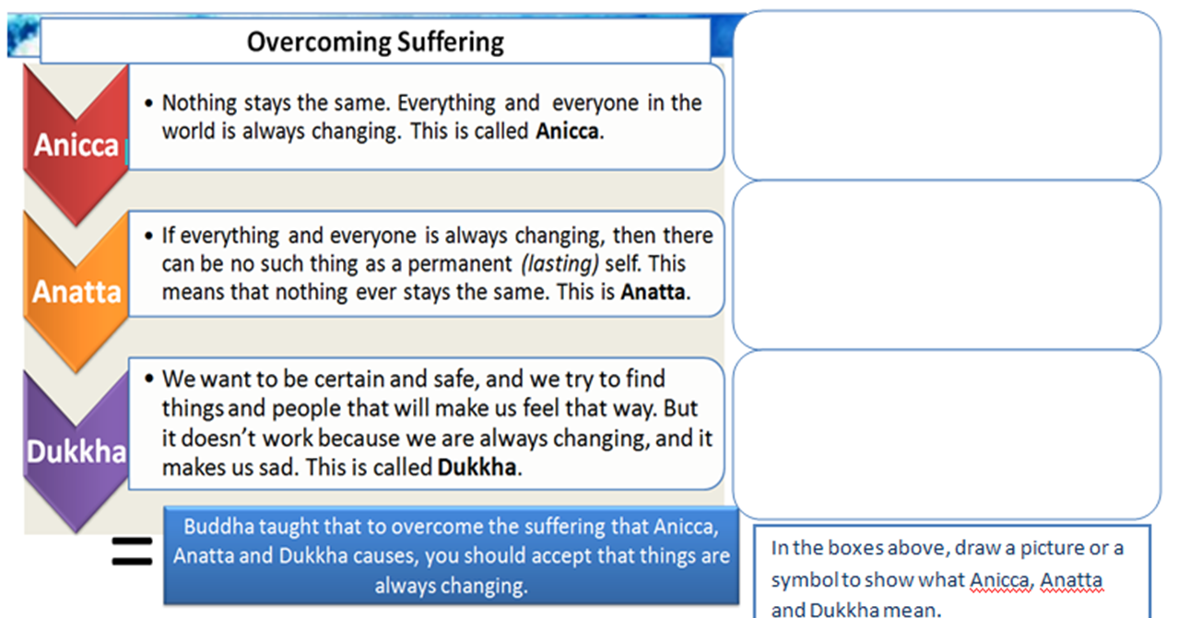
For each step draw or find a suitable image from the internet to describe Anicca, Anatta and Dukkha

Extra challenge! Create your own modern day solution for over-coming suffering
Main task 3
Read through the statements and decide if they are true or false
- Anicca is the idea that nothing stays the same
- Dukkha is the idea that everyone and everything is always changing
- Anicca is the idea that everyone in the world is always changing
- To overcome suffering the Buddha said you have to accept that things will never change
- Anatta means that there are no such things that are permanent

Plenary
‘It is too difficult for Buddhists today to accept that things are always changing’

Do you agree? Explain with two reasons

Lesson 4 – The 4 Noble truths

Lesson objectives
- Understand what the 4 Noble truths are
- Explain how people can use the 4 Noble truths to overcome cravings and suffering

Settler
Think back to last lesson and match the definitions to the correct keyword
Nothing ever stays the same
Anicca

Everyone in the world is always changing
Anatta
We feel sad when things change and don’t stay the same
Dukkha

Don’t forget to self-mark after!

Starter
Write down 3 cravings or things you want right now and why you want them
- This is because…

- This is because…

- This is because…

Q1: How does it make you feel to not have these and why?
Q2: Why might having these items not make you happy? E.g. Having the latest iPhone might not make you happy as there will always be a newer model released.
Main task 1
The Buddha came up with a solution to suffering. When people are ill they go to a doctor to find out what is wrong. The Buddha is often compared to a doctor who diagnoses (recognises) the suffering of the world and then offers a cure. His diagnosis – what he recognises as the problem and his cure for it – is summed up in the Four Noble Truths.

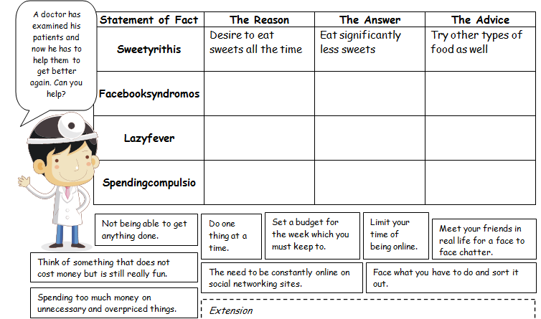
To help you understand here is a table of four terrible diseases. You need to help the patients get better by filling in the table. The answers are underneath.

Don’t forget to self-mark!
Extra challenge! - Create your own terrible diseases and describe what they can cause to happen to you.

Main task 2
Complete the gap fill to find out what the 4 Noble truths are
The first Noble truth contains the f_________. Buddha believed that there would always be some form of s__________ in life or a feeling that life is not p___________. The 2nd Noble truth is the reason we experience suffering. Buddha believed it is caused by us wanting m_________ and m_________. This feeling of wanting brings u_________________ because we are always changing. The 3rd noble truth contains the g____________. Buddha believed that we must accept that things c__________. He believed that we must avoid s_______- c____________ and try to h_______ others. This will make us happier. The 4th Noble truth gives u s a___________. Buddha taught that if we follow the noble e_____________ p_____, we could use his a________ to live in p_______ with others and ourselves.
Missing words

guidance change facts suffering more advice help eightfold path more unhappiness perfect answer happier self-

A way to explain surffering from cravings is…
You might be really hungry, so you eat your favourite meal. But a few hours later you feel hungry again. This shows how everything in life is constantly changing – your happiness never lasts.

Now come up with your own example to demonstrate how people suffer from cravings

Questions for reflection
- Do you believe the 4 Noble truths apply to everything in the world?

- Are the 4 Noble truths relevant today for Buddhists today?

- Do you agree that ‘everywhere there is suffering’?

- Do you think that disconnecting ourselves from all material things would be beneficial or harmful?

Task 3 – The story of Kisa Gotami
The Buddha taught the 4 Noble truths to people to help them understand how to overcome suffering from cravings. Read the story below and answer the questions after
During Buddha’s time, there lived a woman named Kisa Gotami. She married young and gave birth to a son. One day, the baby fell sick and died soon after. Kisa Gotami loved her son greatly and refused to believe that her son was dead. She carried the body of her son around her village, asking if there was anyone who can bring her son back to life.
The villagers all saw that the son was already dead and there was nothing that could be done. They advised her to accept his death and make arrangements for the funeral. In great grief, she fell upon her knees and clutched her son’s body close to her body. She kept uttering for her son to wake up.
A village elder took pity on her and suggested to her to consult the Buddha.
“Kisa Gotami. We cannot help you. But you should go to the Buddha. Maybe he can bring your son back to life!”
Kisa Gotami was extremely excited upon hearing the elder’s words. She immediately went to the Buddha’s residence and pleaded for him to bring her son back to life.
“Kisa Gotami, I have a way to bring your son back to life.”
“My Lord, I will do anything to bring my son back”
“If that is the case, then I need you to find me something. Bring me a mustard seed but it must be taken from a house where no one residing in the house has ever lost a family member. Bring this seed back to me and your son will come back to life.”
Having great faith in the Buddha’s promise, Kisa Gotami went from house to house, trying to find the mustard seed. At the first house, a young woman offered to give her some mustard seeds. But when Kisa Gotami asked if she had ever lost a family member to death, the young women said her grandmother died a few months ago. Kisa Gotami thanked the young woman and explained why the mustard seeds did not fulfill the Buddha’s requirements.
She moved on to the 2nd house. A husband died a few years. The 3rd house lost an uncle and the 4th house lost an aunt. She kept moving from house to house but the answer was all the same – every house had lost a family member to death.
Kisa Gotami finally came to realise that there is no one in the world who had never lost a family member to death. She now understood that death is inevitable and a natural part of life. Putting aside her grief, she buried her son in the forest. She then returned to the Buddha and became his follower.

Question - What do you think the Buddha was trying to teach in the story of Kisa Gotami?

Plenary
Do you think that accepting that there is suffering will make you feel happy and enlightened? Explain your answer.
I think that accepting that there is suffering will make me feel... because...

Another reason I feel this way is because...

Lesson 5 – Is it easy to be a Buddhist teenager and follow the eightfold path?

Lesson objectives
- To describe what the Eightfold Path is.
- To explain the significance of the Eightfold path for Buddhists
- To consider the challenges Buddhist teenagers may face following the Eightfold path and other Buddhist teachings

Settler
Think back to last lesson and answer the short answer questions

- What did the Buddha say the 4 Noble truths help to solve? [1 mark]

- Unhappiness b) Death c) Reincarnation d) Suffering

- Name two things Buddhists can learn from the story of Kisa Gotami [2 marks]
- ________________________________
- ________________________________
Don’t forget to self mark!

Starter - What are some of the challenges a Buddhist teenager might face today?
List 3 things a teenager might suffer with today (e.g. stress from revision for GCSE exams)
1)
2)
3)
Question - Thinking back to the 4 noble truths, how might getting rid of craving help a Buddhist teenager today?

Main task 1 – What is the eightfold path?
Complete the gap fill to find out what the eightfold path is

The B________ told people to follow the advice of the E_________ Path. This path sets out the Buddha's guidance on how to live so that you are at p_____ with yourself and the world.
To Buddhists, the Eightfold Path is the r______ way to live. It is not a list of r______, but are principles that can be applied to everyday s__________.
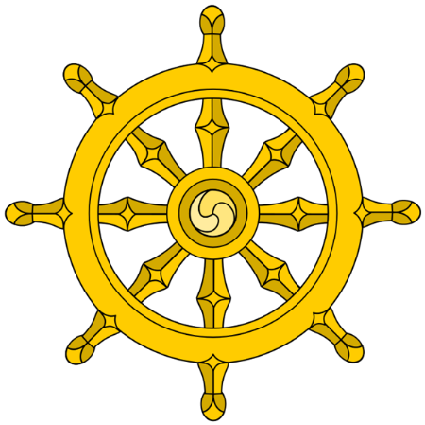
Buddhists believe that if they follow the Eightfold path, they can overcome s__________ and desire, and achieve e_____________.
There have been many i_______ of the Eightfold Path produced throughout h__________ to try and explain what it is and to help Buddhists in the practice of the Path. Many are based on an eight-spoke wheel.

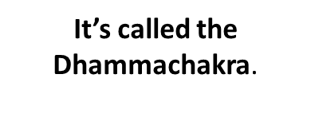
MISSING WORDS – Suffering, History, Buddha, Rules, Enlightenment, Images, Eightfold, Right, Peace, Situations.

- Now summarise what the eightfold path is in ONE sentence!

Main task 2 – What are the principles in the eightfold path and how can it help a Buddhist teenager today?

You are now going to learn what each principle is in the eightfold path. Read through each of them and draw a picture/symbol or find a suitable image from the internet to show your understanding. Some of them already have an image to help you.




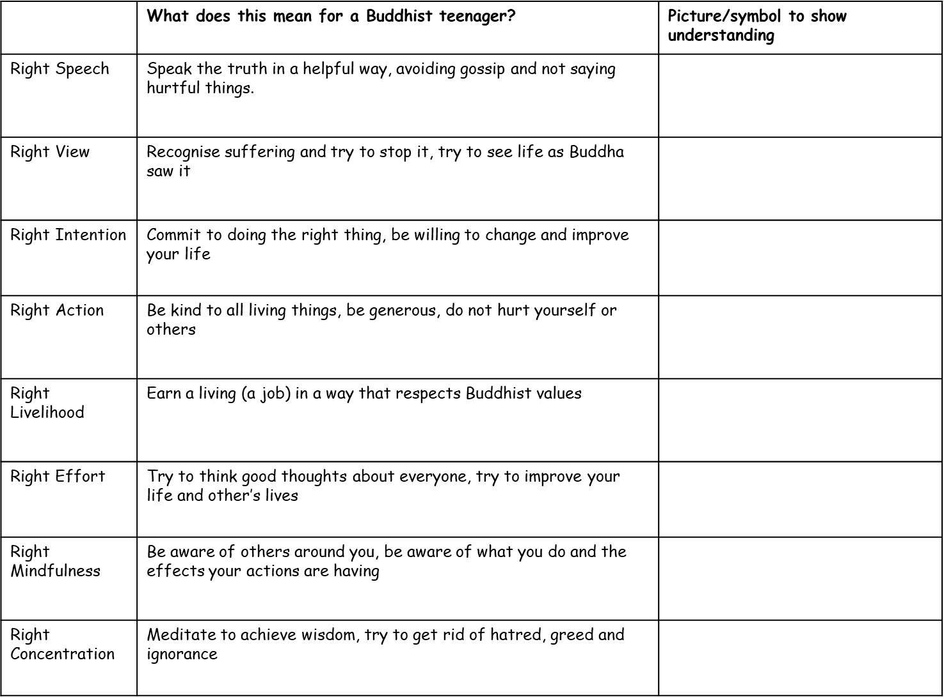
Task – Choose 3 of the principles from the eightfold path and explain how a Buddhist teenager might put these into practice (in real life). Look at the example below to help you and the sentence starters to help you structure your answers.

Example - A Buddhist teenager might put right put ‘right speech’ into practice by not joining in gossip at school about one of their friends. They would speak the truth by telling their friends what they are doing is wrong.
SENTENCE STARTERS
A Buddhist teenager might put right… into practice by…

Reflection question: Do you believe it would be easy or difficult for a Buddhist teenager to follow the eightfold path today? Explain with two reasons

Explain how following the eightfold path would help a Buddhist teenager today

Extra challenge: The Eightfold path “gives rise to vision, which gives rise to knowledge, and leads to peace, to direct knowledge, to enlightenment, to Nirvana (liberation) - What does this quote tell Buddhist teenagers about the importance of following the Eightfold path.

Plenary
True or false quiz. Decide if the statements are true or false

- Right livelihood means to have a job that goes against Buddhist principles
- Right speech means to always speak the truth
- To achieve right concentration a Buddhist teenager could meditate
- Right action means to recognise suffering and try to stop it

Create your own true or false question about the eightfold path
Don’t forget to self-mark!

Lesson 6 – The 5 moral precepts
Lesson objectives
- To describe what the Five Precepts are.
- To explain the importance of following the five precepts for Buddhists.
- Compare the 5 moral precepts to the eightfold path.

Settler
Create a tweet about what you learnt last lesson. Don’t forget to hashtag keywords you learnt.


Starter
Come up with five rules, which you think everyone should live by and explain why you have chosen these rules.
For example, don’t use violence to get your own way.
SENTENCE STARTERS TO HELP YOU
Rule 1: …
I have chosen this rule because…

Reflection question: Why do we have rules?

Main task 1 – What are the 5 moral precepts?
In Buddhism there are a set of rules called the 5 moral precepts. Watch the video and use it to help you fill out the table below
YouTube link: https://www.youtube.com/watch?v=j1A2D1X4EaU
Website link: https://www.bbc.co.uk/bitesize/guides/zf8g4qt/revision/9

Moral precept | What is it? | Explain an example of how Buddhists put the precept into practice (real life example)

Extra challenge! How does the 5 moral precepts compare to other religious rules? For example Kosher in Judaism and the 10 commandments

Reflection question: Which precept do you believe is the most important for Buddhists and why?

Main task 2 - How could you follow the 5 Moral Precepts in your life?
For each Moral Precept, write an example which shows how you could follow the rules in your everyday life.
For example - I would follow the first moral precept by using a piece of paper to catch a spider and put it outside, instead of killing it, if I saw a spider in the classroom.

SENTENCE STARTERS
I would follow the first/second/third/fourth/fifth precept by...
This is because...

STAR
“The most important moral precept is to avoid untrue speech” (6 marks)
Evaluate the statement by writing…
- X 2 reasons why someone would agree with the statement
- X 2 reasons why someone would disagree with the statement
- A reason why a Buddhist would agree and a reason why they would disagree with the statement
- Your opinion about the statement
SENTENCE STARTERS TO HELP YOU STRUCTURE YOUR ANSWER
One reason why someone might agree with the statement is because…
Another reason why someone might agree with the statement is because…

However, someone might agree with the statement because…
Another reason why someone might disagree with the statement is because…

Some Buddhists may agree with the statement because…
However some Buddhists may disagree with the statement because…

Overall, I agree/disagree with the statement because…

Plenary
It is more important for a Buddhist to follow the eightfold path than the 5 moral precepts
Do you agree? Explain with a developed reason
Lesson 7 – Karma and Reincarnation
Learning objectives
- To understand what Karma and Reincarnation are.
- To explain Buddhist beliefs about Reincarnation and Karma.
- To consider our own beliefs about Reincarnation.

Settler
- What religion is this unit about?
- Why are we learning about it?
- How does this topic link to one other you have learnt about this year?

Starter
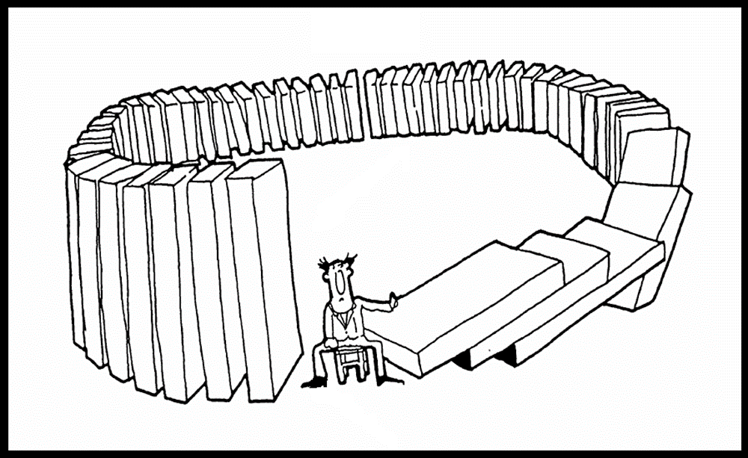

Look at the picture and answer the questions below
- What is happening in this picture?
- What will be the consequences?
- What do you think it means about life?
- Do you have any questions about the picture?

Main task 1 – What is Karma?
Karma – The law that good actions and thoughts have good consequences and bad actions and thoughts have bad consequences.
What does ‘consequence’ mean? ‘Consequence’ is the word we use to describe the effect of something. It is what happens after an action. For example, if you don’t do your homework, then the consequence will be a detention.

Give an example of good karma –

Give an example of bad karma –

Buddha found that the easiest way to explain something that is difficult to understand is to use stories. The story that Buddha used to help us understand Karma is called ‘The hunter and the monkeys’. Read the story below and answer the questions after.
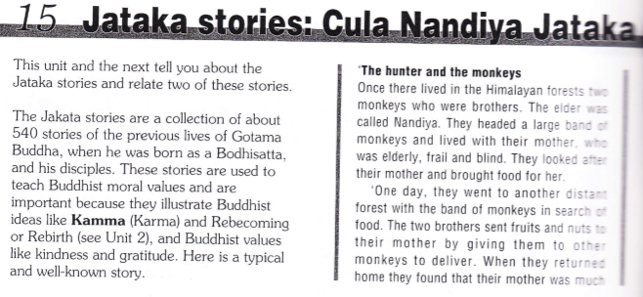
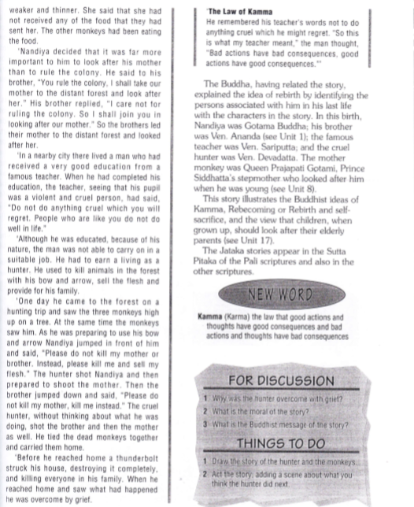

Questions
- What happened to the hunter?
In the story, the hunter…
- Why did this happen to him?
This happened to the hunter because…
- What is Buddha’s message of the story?
In the story, Buddha is trying to tell us that…
- Did the story help you understand what karma is? Why?
The story did/didn’t help me to understand karma because…
- Do you think telling a story to explain something is better than just given a definition? Why?
I think telling a story to explain something is…

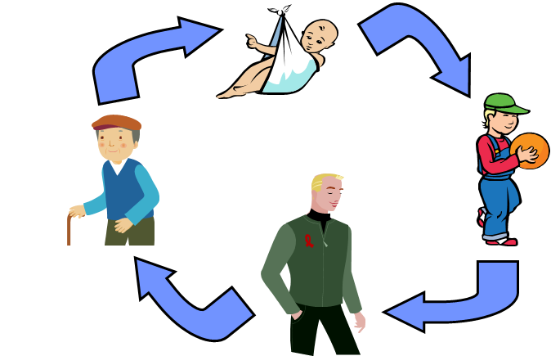
Main task 2 – How are Karma and Reincarnation linked?
Buddhists believe in ‘reincarnation’. They believe that when someone dies, their karma remains and that it is born again to live a new, different life.
In Buddhism, this is called ‘samsara’ which means the ‘cycle of rebirth’ – the repeating cycle of birth, life, death, and rebirth.

Depending on their karma, a person will be reborn as a human if the karma is good...or as an animal if the karma is bad.
Buddhists also believe that you keep getting reborn, until you remove all your bad karma and understand how to stop suffering. Once you’ve done this, you go to nirvana, which is a state of pure happiness.
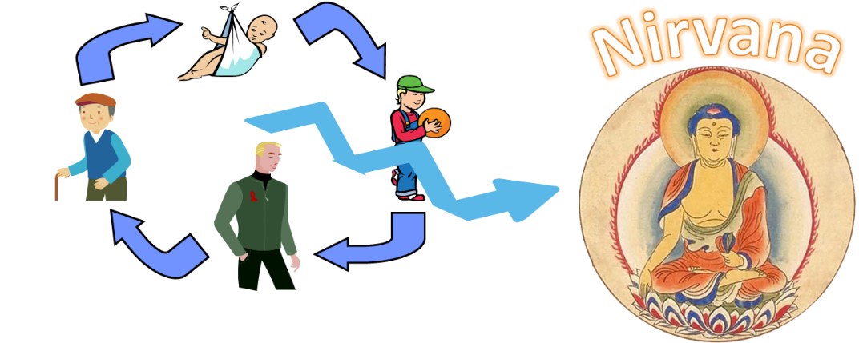

Now come up with your own definition of Reincarnation (use the help box if you are stuck)-
Buddhists believe in reincarnation. This means...
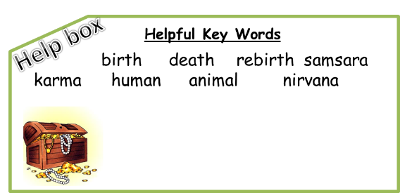
How are Karma and Reincarnation linked?
Karma and Reincarnation are linked because…

Main task 3 – Do you believe in past lives?
Here is a real life story about someone who believes they have 'lived before'. Read it and then complete the task underneath.

Five-year-old Imad Elawar from Lebanon started talking about his life in a nearby village. The first two words he spoke as a child were the names “Jamileh” and “Mahmoud,” and at the age of two he stopped stranger outside and told him they had been neighbours. The child and his parents were investigated by Dr Ian Stevenson. Imad made over 55 different claims about his previous life.
The family visited the village that the boy had been spoken of, together with Stevenson, and found the house where he claimed he had lived. Imad and his family were able to positively identify thirteen facts and memories that were confirmed as being accurate. Imad recognized his previous uncle, Mahmoud, and his mistress from a former life, Jamileh, from photographs. He was able to remember where he had kept his gun, a fact verified by others, and was able to have a chat with a stranger about their experiences during their army days. In total, 51 out of 57 of the experiences and places mentioned by Imad were verified during the visit.

- How does this story show reincarnation?
- What would a Buddhist say about this? Would they believe it is true?
- Do you believe that reincarnation is real? Explain with two reasons
I do/don’t believe that reincarnation is real. This is because…
Another reason for my belief is…
Extra challenge! Create your own story to demonstrate Karma and Reincarnation

Plenary
Explain two influences of Karma and Reincarnation for Buddhists today [4 marks]
Remember – influence means how a Buddhist is going to think/feel/behave/not do/do because of their belief.

One influence of Karma/Reincarnation for Buddhists today is that… This is because…

Another influence of Karma/Reincarnation for Buddhists today is that… This is because…

Lesson 8 – Meditation
Lesson objectives
- Understand what meditation is
- Explain why it is important for Buddhists
- Evaluate its effectiveness for achieving enlightenment

Settler
Thinking back to all your topics, you have learnt so far… answer the questions below
- What were the 4 sights that the Buddha saw?
- What symbol is often used to represent the eightfold path?
- How many moral precepts are there for Buddhists?
- What did the Buddha say was the cause of suffering?
- If you build up lots of good karma what will you come back as?

Starter

Imagine a place of pure peace. What would it be like? Draw it or explain it.

Main task 1 – what is meditation?
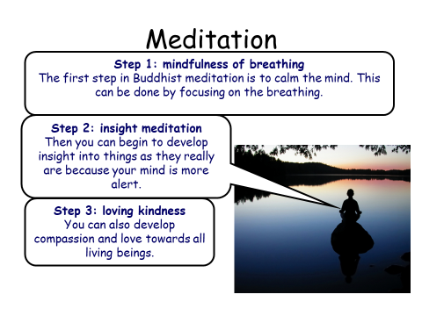
Enlightenment is to have an understanding of the nature of reality. You understand what is real, and what is truth. The Buddha became aware of three things when meditating that helped him reach Enlightenment.

Complete the gap fill below
Meditation is a time for q……………. thinking and r………………….. The Buddha became enlightened during deep meditation under the b……………… t……………. By meditating Buddhists believe that they will become better people and reach e…………………………. It calms the m……………… and the b……………….It is a central practice in B………………….

Missing words – Quiet Mind Enlightenment Bodhi Tree
Reflection Body Buddhism

Now it’s time for you to try meditation! Follow the YouTube link and do meditation.
https://www.youtube.com/watch?v=inpok4MKVLM

Q1) How did you feel when you meditated and why?

Main task 2 – why is meditation important for Buddhists?

There are lots of reasons why Meditation is important for Buddhists. Below are 4 reasons, your task is to order them in reasons of importance.

- All that we are is the result of what we have thought: it is founded on our thoughts, it is made up of our thoughts (Dhammapada). These lines from the Dhammapada suggest that the mental states we experience are the key to everything in our lives.
- Buddhists believe that meditation stops craving. This is because we will experience the world with kindness, calm and love.
- The only way to reach Nirvana is to become enlightened and meditation is how the Buddha achieved this.
- There is research that suggests meditation can improve people’s mental well-being.

- Order the statements using the boxes next to them with 1 being the most important and 4 being the least.
- Explain your first and last choice using a well explained reason for each.
SENTENCE STARTERS
I have chosen 1 as the most important reason. This is because…

I have chosen 4 as the least most important reason. This is because…

Extra challenge! Create a ‘beginners guide to meditation’

Plenary
Create 3 quiz questions about meditation for a friend to answer

Lesson 9 – What can Buddhists learn from the life of the Buddha?

Learning objectives
- Explain how the teachings of the Buddha can affect Buddhists today
- Evaluate which of the Buddha's teachings are the most important for Buddhists

Settler
‘All religious people should practice meditation’ – Do you agree? Explain with a detailed reason

Starter
Break down the Buddha's life into 3 stages (if you are stuck look back at your work from lesson 2).
1)

2)

3)

Reflection question: Which stage do you think has the most influence for Buddhists today and why?

Main task 1 – What can Buddhists learn from the life of the Buddha?
Throughout this topic you have learnt all about the teachings of the Buddha. The Buddha taught that we should us the eightfold path to help overcome suffering and achieve enlightenment.
He also taught that there are 3 kinds of good action that lead to happiness

1. Giving/Kindness
2. Harmlessness (e.g. three of the Five Precepts: No killing, stealing or
lying)
- Meditation

Question: How do you feel when you have been selfish rather than kind?

Demonstrating harmlessness

Ask this spider about his life – rather than being scared and wanting to get rid of/killing it

How did you feel doing this?

These questions were designed to demonstrate that good thoughts lead to good actions. This task got you to have empathy for the spider, which is what the Buddha wanted.

- How did you feel asking the spider about his life?

- Explain why Buddhists would want to follow these 3 good actions in their lives

Main task 2 – How are Buddhists influenced by the life of the Buddha?
Some Buddhists are so influenced by the Buddha and his teachings that they decide to fully dedicate their lives to their religion by becoming monks.
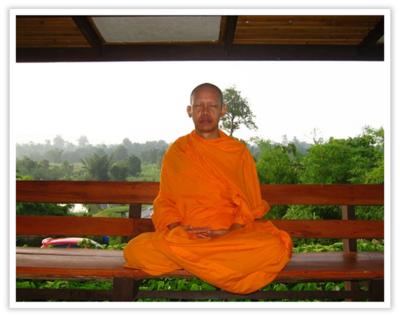
As you can see from the picture, monks dress as simply as Buddha would have done. They also spend a lot of time meditating.

Watch this video and answer the questions after
https://www.youtube.com/watch?v=8AeSsJGUGDA
- Why is meditation important for the monks?
Meditation is important for the Monks because….
- How have the monks been influenced by the Buddha's teachings?
The Monks have been influenced by the Buddha’s teachings because…
- Explain how Gordon felt as someone who isn’t a Buddhist
Gordon felt… This was because…

All Buddhists should follow five precepts. Monks must follow ten. The precepts have been muddled up below. You must sort these into two categories: those all Buddhists should follow; those only monks need to follow.
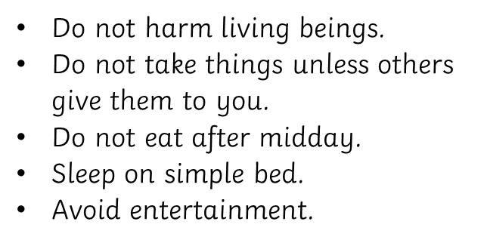

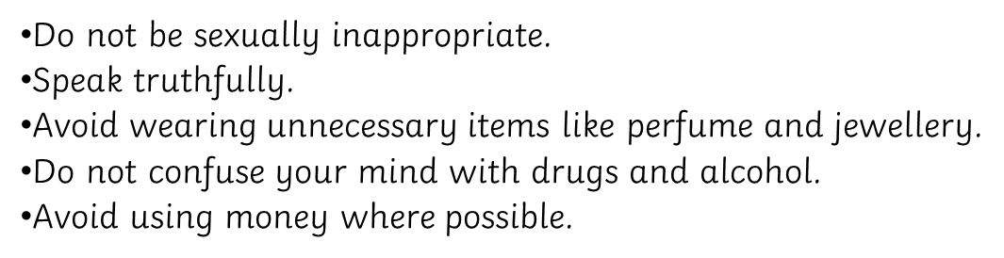

Precepts ALL Buddhists must follow | Precepts only Monks follow
1)  2)  3)  4)  5) | 1)  2)  3)  4)  5)

Don’t forget to self-mark after!

Extra challenge! Could you live as a monk? Explain your answer.

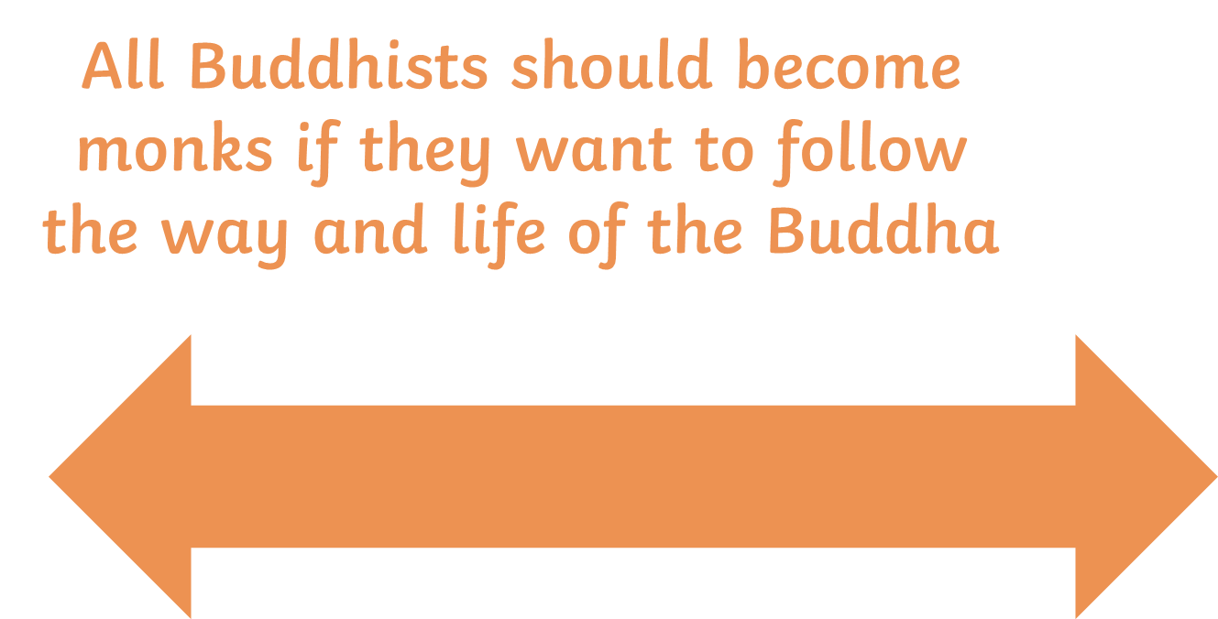
Plenary

No
No
Yes

Where would you place yourself on this line and why?

Lesson 10 – Inspiring Buddhist leader: Thich Nhat Hanh

Lesson objectives
- To understand some of the history surrounding the Vietnam War
- To explore the life and teachings of Thich Nhat Hanh
- To reflect on how Thich Nhat Hanh’s teachings may inspire our own lives

Settler
Name two precepts that only Buddhist Monks must do [2 marks]
- _____________________
- _____________________
Don’t forget to self-mark!

Starter
To understand who Thich Nhat Hanh is, you must first learn about the Vietnam War that took place between November 1, 1955 - April 30, 1975.

Read the information below

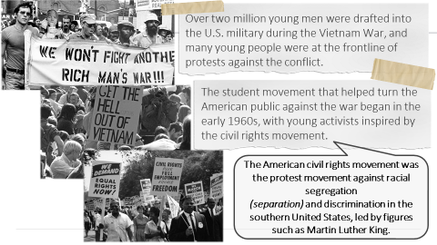

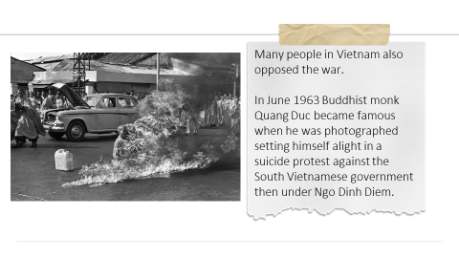

Write down 5 things you have learned about the Vietnam war
1)
2)
3)
4)
5)

Main task 1 - So who is Thich Nhat Hanh and how does he link to the Vietnam War?
As you watch, write down at least x3 new things you have learnt about Thich Nhat Hanh . One of your points must be about the Vietnam War.
YouTube link: ONLY WATCH UNTIL 8.26 MINS
https://www.youtube.com/watch?v=NJ9UtuWfs3U

Main task 2 – Why is Thich Nhat Hanh inspirational?
Using this website: https://plumvillage.org/about/thich-nhat-hanh/ and what you have learnt so far you are going to produce a creative piece about him. This could be…
- A leaflet/poster
- A speech
- A television/social media advert
- A song/rap
- A poem

Extra challenge! Research and find out about another inspiring Buddhist

Plenary
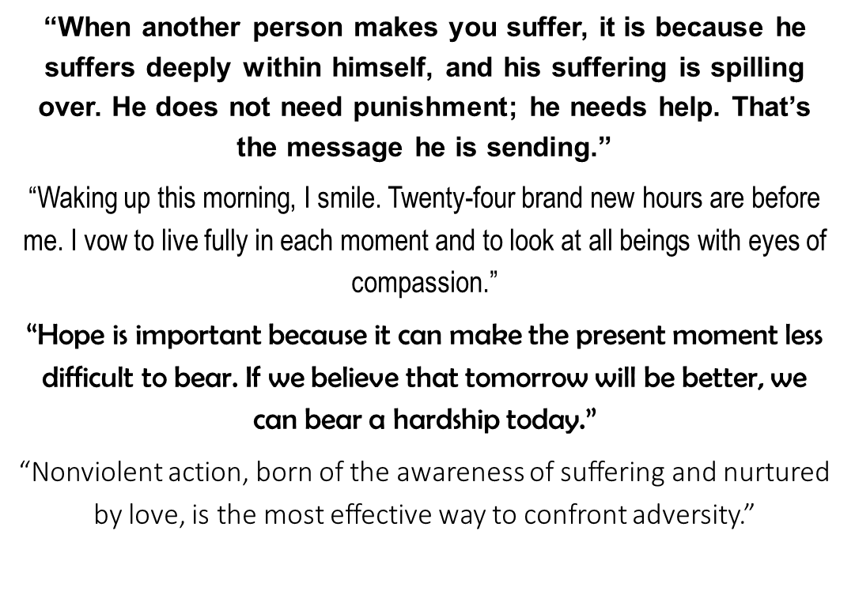

- Choose one of Thich Nhat Hanh’s quotes.

- How could this quote inspire you in your day to day life?

Answers for self-assessing

Lesson 1 – Introduction to Buddhism
Starter
- India
- 2500 years
- 470 million
- Siddhartha Gautama
- Enlightened
- Lotus flower, Dharma wheel, Bodhi tree, Swastika
- True

Lesson 2 – The early life of Siddhartha
Plenary
- C) Suffering
- B) Flowers
- Any two of the following – A sick man, a dead man, an old man and a holy man

Lesson 3 – Enlightenment
Starter
Unscrambled definition is: Enlightenment means to know the truth, through meditation, Buddhists try to find out the truth about the universe. When a Buddhist has achieved enlightenment they will reach Nirvana (release from the cycle of reincarnation).
Main task 3
- False
- False
- True
- False
- True

Lesson 4 – 4 Noble truths
Settler
Anicca
Anatta
Dukkha
Nothing ever stays the same
Everyone in the world is always changing
We feel sad when things change and don’t stay the same

Main task 1
Answers for the doctors surgery task
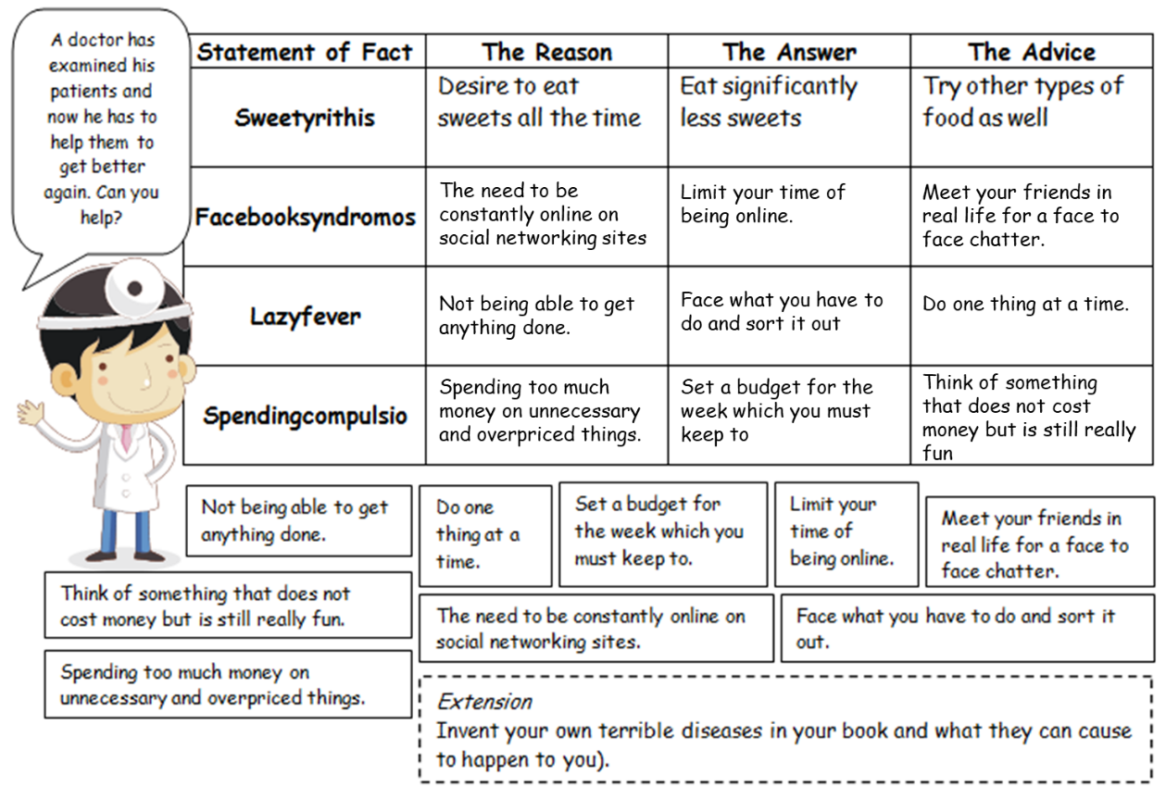

Lesson 5 – Eightfold path
Settler
- D – suffering

- How to overcome suffering
- How to understand that nothing is ever permanent
- How to control wanting and craving
- How to become enlightened
- How to understand death
Plenary
- False
- True
- True
- False

Lesson 8 – Meditation
Settler
- Holy man, sick man, dead man and an old man
- A 8 point wheel (Dharma wheel)
- 5
- Craving
- A human

Lesson 9 – What can Buddhists learn from the life of the Buddha?
Main task 2
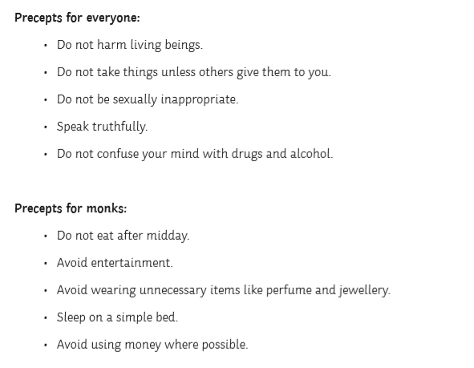

Lesson 10 – Inspiring Buddhist leader
Settler
Any two of the following
- Not eating after midday
- Avoiding entertainment
- Avoiding unnecessary items like perfume and Jewellery
- Sleeping on a simple bed
- Avoid using money where possible

